**Final Documentation**

Anil Kumar Paili

Department of Computer Science, Monroe Graduate School

Prof Nicholas Nardi

April 10, 2025

Table of Contents

**0.0 DOCUMENTATION MANAGEMENT** 5

**0.1 Revisions and Distribution** 5

**0.2 Project Authorizations** 6

**0.3 Project Sponsor Approval of Scope Statement** 7

**1.0** **PROJECT CHARTER** 8

**1.1** **Project Authorization** 8

**1.2**  **Executive Summary** 8

**2.0** **BUSINESS OBJECTIVES AND EXPECTED BENEFITS** 9

**2.1** **Business Need, Opportunities, Objectives** 9

Business Need 9

Opportunities 10

Business Objectives 10

**2.2** **Proposed Solution** 11

Benefits of the Project: 12

Success Criteria: 12

**2.3** **Project Deliverables** 13

Deliverables Included: 13

Deliverables Excluded: 14

**2.4** **Anticipated Benefits** 15

**3.0** **PROJECT DESCRIPTION** 17

**3.1** **Functionality Inclusions** 18

**3.2** **Functionality Exclusion** 19

**3.3** **Completion and Acceptance Criteria** 20

**3.4** **Risk Assessment** 21

**3.5** **Constraints** 21

**3.6** **Dependency Linkages** 22

**3.7** **Impacts** 23

**3.8** **Measures of Project Success** 24

**3.9** **Assumptions** 25

**3.10** **Critical Success Factors** 26

**4.0** **FUNCTIONAL REQUIREMENTS** 27

**4.1** **Business Functional Requirements by Group** 27

**4.2** **System Functional Requirements** 28

**5.0** **PROJECT APPROACH** 30

**5.1** **Planned Approach** 30

**6.0** **PROJECT COST AND RESOURCE ESTIMATES** 32

**6.1** **Major Milestones - Estimated Schedule** 32

**6.2** **Resource Requirements – Team and Support Resources** 32

Resource Assumptions: 33

**6.3** **Estimated Costs** 34

**7.0** **PROJECT CONTROLS** 35

**7.1** **Checkpoint Funding Schedule** 35

**7.2** **Weekly/Monthly Status and Steering Committee Meetings** 35

**7.3** **Weekly/Monthly Status Reports** 36

**7.4**  **Risk Management** 36

**7.5** **Issue Management** 37

**7.6** **Change Management** 37

**7.7** **Communication Management** 38

**8.0** **ADDITIONAL PROJECT DETAILS** 39

**9.0** **PROJECT DICTIONARY** 41

**10.** **PROJECT ROLES AND STAKEHOLDERS** 45

**10.1** **Project Roles** 45

**10.2** **Project Stakeholders** 47

**Project Plan, Project Budget, and Gantt Chart** 51

Breakdown Explanation 53

3. Present Value Calculation (NPV) at 5% Discount Rate 55

**DFD and User Stories** 58

Database Design with ERD 75

**Network Design and Security** 85

Application Design 95

**1. Login Process & Role-Based Access** 96

**2. Patient Dashboard** 96

**3. Healthcare Provider Dashboard** 97

**4. Admin Dashboard** 98

**5. Key Observations & Functional Flow** 99

# **0.0 DOCUMENTATION MANAGEMENT**

## **0.1 Revisions and Distribution**

This document may be revised periodically to reflect updates in project scope, requirements, or implementation details. The project manager will log, review, and approve all revisions before they are distributed to stakeholders.

|  |  |  |  |  |
| --- | --- | --- | --- | --- |
| **Version** | **Date** | **Description** | **Author** | **Approval** |
| 1.0 | February 1, 2025 | Initial Draft | Anil Kumar Paili | Project Sponsor |
| 1.1 | February 1, 2025 | Updates to the project approach | Anil Kumar Paili | Project Manager |
| 1.2 | February 1, 2025 | Cost and resource refinements | Anil Kumar Paili | Development  Team |

The Project Scope Management Plan from time to time may require updates. ALL amendments to this plan shall be informed to the change control board by use of the change request form and approved by the project change control board prior to distribution. Only revised parts of the plan will be distributed along with the approval and shall be accompanied by instructions how to implement the changes.

The initial page numbering system (to be added upon initial approval) will be a normal continuous numbering displayed in the lower right corner of each page. In the event that pages have to be added, characters shall be added to the number. In case entire pages are deleted, the corresponding page shall be replaced by a blank page stating “page removed”.

Each added/changed page shall have the revision number and date of approval displayed on the bottom of the page.

## **0.2 Project Authorizations**

As the sole project handler, I, Anil Kumar Paili, am responsible for the authorization, execution, and management of all aspects of this project. This includes requirements gathering, design, development, deployment, and maintenance. I will make all project-related decisions, revisions, and approvals in alignment with the project's objectives and constraints.

Regular documentation updates will be made to maintain transparency and track progress, and all project milestones will be documented. Any external assistance, consultation, or resource utilization will be recorded for future reference.

The Scope Statement will be approved by:

1. Project Manager
2. Project Owner
3. Project Sponsor

Project Changes will be approved by:

1. Project Owner

Project deliverables will be approved/accepted by:

1. Project Owner
2. Project Sponsor
3. Key Stakeholders

Specific task responsibilities of project resources will be defined in the Project/Work Plan.

## **0.3 Project Sponsor Approval of Scope Statement**

The scope statement for the Healthcare Appointment Management System (HAMS) has been reviewed and approved. This document accurately defines the objectives, deliverables, constraints, assumptions, and success criteria for the project. By approving this scope statement, the project sponsor acknowledges their support for the project's execution as outlined.

Signatures below indicate that the information contained in this document has been reviewed and agreed upon.

|  |  |  |  |
| --- | --- | --- | --- |
| **REVISION ID** | **REVIEWR NAME** | **REVIEWER ROLE** | **APPROVED DATE** |
| HAMS-001 | Anil Paili | Project Manager | February 16, 2025 |
|  |  |  |  |
|  |  |  |  |
|  |  |  |  |

# **1.0 PROJECT CHARTER**

## **1.1 Project Authorization**

The primary purpose of this Project Charter is to document and obtain approval for work needed to complete the project inside this charter…approval is needed before the allocation of resources and authorization to commence work…

A project’s charter is typically evaluated against other charters…only select projects are authorized to proceed…the charter should properly highlight the benefits of the project as well as potential risks.

## **1.2 Executive Summary**

The purpose of this scope document is to detail the scope of work for the Healthcare Appointment Management System (HAMS) project. The project's purpose is to make scheduling appointments for patients efficient and optimized, with reduced waiting times and increased overall efficiency in providing healthcare service (Youn et al, 2022). With this system, an efficient and simple platform will be facilitated for administration, physicians, and patients for effective management of appointments.

The Healthcare Appointments Scheduling System is an electronic platform through which appointments can be scheduled with ease (Cox III, & Boyd, 2020). Patients will be able to book, modify, and cancel appointments via an electronic platform, and providers will have effective tools for scheduling and managing appointments. Automated reminders and alert will also be facilitated in a move to minimize no-shows and save both providers' and patients' time.

# **2.0 BUSINESS OBJECTIVES AND EXPECTED BENEFITS**

The Healthcare Appointment Management System (HAMS) is designed to address inefficiencies in traditional appointment scheduling. The current process leads to long wait times, high no-show rates, and administrative overload. This project aims to provide an AI-driven scheduling solution that automates appointment bookings, reduces operational costs, and enhances patient satisfaction. By optimizing appointment management, the system will improve overall healthcare service delivery.

## **2.1 Business Need, Opportunities, Objectives**

The need for an automated, AI-driven solution was identified based on stakeholder feedback and an operational review conducted in Q4 2024.

### Business Need

1. **Operational Inefficiencies**: Healthcare facilities experience up to 30% no-show rates due to ineffective reminder systems and manual scheduling processes.
2. **Rising Workload**: Increased patient volume has overwhelmed administrative staff, leading to scheduling errors and miscommunication.
3. **Patient Dissatisfaction**: Surveys indicate that 45% of patients are dissatisfied with the current appointment booking experience due to long wait times and lack of visibility into available time slots.
4. **Revenue Loss**: Missed appointments contribute to a 15% loss in potential revenue for healthcare providers.

### Opportunities

1. **AI-Driven Scheduling**: Implementing AI algorithms to match patient needs with physician availability more efficiently.
2. **Digital Transformation**: Leveraging digital tools to modernize appointment booking, reducing dependency on manual processes.
3. **Improved Communication**: Introducing automated SMS, email, and app notifications to improve communication and minimize missed appointments.
4. **Enhanced Patient Engagement**: Providing an intuitive patient interface that increases engagement and satisfaction.

### Business Objectives

1. **Reduce No-Show Rates by 25%**: Implement automated reminders and online rescheduling capabilities.
2. **Increase Scheduling Efficiency by 35%**: Optimize the booking process through an intuitive interface and AI-driven recommendations.
3. **Enhance Patient Satisfaction by 30%**: Improve user experience through real-time updates and self-service options.
4. **Decrease Administrative Workload by 40%**: Automate appointment management tasks to allow staff to focus on patient care.
5. **Increase Revenue by 20%**: Minimize lost revenue from missed appointments and improve resource utilization.

**Magnitude of the Need/Opportunity:** Healthcare facilities currently lose thousands of dollars monthly due to inefficient scheduling. A scalable, user-friendly platform will address these challenges by introducing automation and real-time communication features.

**Contributing Factors:**

1. A 25% rise in patient appointments over the past year.
2. Staffing shortages within administrative departments.
3. Increasing patient demand for convenient, self-service booking solutions.

**Consequences of Inaction:**

* Continued high no-show rates leading to reduced operational efficiency.
* Lower patient satisfaction, negatively impacting the facility's reputation.
* Increased workload and burnout among administrative staff.
* Persistent revenue loss due to missed appointments and inefficient resource allocation.

By implementing HAMS, NeoHealth Systems aims to modernize appointment scheduling, improve healthcare delivery, and enhance patient and provider experiences.

## **2.2 Proposed Solution**

The proposed solution is the implementation of the Healthcare Appointment Management System (HAMS), an AI-driven, web-based platform designed to streamline the scheduling process for healthcare appointments. This system will facilitate efficient appointment booking, management, and tracking for patients, healthcare providers, and administrators.

**Solution Description:**

* Development of a secure, user-friendly platform accessible via web and mobile applications.
* Integration of AI-driven algorithms for optimal scheduling and real-time availability updates.
* Implementation of automated notifications (SMS, email, and in-app) to reduce missed appointments.
* Creation of an administrative dashboard for real-time monitoring and reporting.
* Secure patient data handling in compliance with healthcare regulations.

### Benefits of the Project:

* **Operational Cost Reduction:** Automating appointment scheduling is projected to reduce administrative workload by 40%, saving an estimated $150,000 annually.
* **Improved Patient Satisfaction:** Enhanced accessibility and intuitive interfaces are expected to boost patient satisfaction ratings by 30%.
* **Increased Appointment Efficiency:** Optimized scheduling and automated reminders will reduce appointment no-show rates by 25%.
* **Better Resource Utilization:** Real-time data and analytics will help healthcare facilities optimize resource allocation.

### Success Criteria:

* **Efficiency Metrics:** Achieving a 35% improvement in appointment scheduling efficiency within the first year.
* **User Satisfaction:** Obtaining positive feedback from at least 80% of patients and staff within six months of deployment.
* **Cost Savings:** Realizing a 40% reduction in administrative costs within the first 12 months.
* **Compliance and Security:** Ensuring 100% compliance with healthcare data protection regulations.

The implementation of HAMS will align with NeoHealth Systems' strategic goal of modernizing healthcare services through digital transformation, ultimately improving patient care and operational efficiency.

## **2.3 Project Deliverables**

The Healthcare Appointment Management System (HAMS) project will produce several key deliverables to ensure the success and effectiveness of the new scheduling platform. The following high-level deliverables have been identified:

### Deliverables Included:

* **Web-Based Scheduling Platform:** A secure, accessible, and responsive application for booking, modifying, and canceling appointments.
* **Mobile Application:** A mobile-friendly application for on-the-go access for patients and staff.
* **Administrative Dashboard:** An interface for managing schedules, viewing reports, and accessing appointment analytics.
* **Automated Notification System:** Integrated SMS, email, and app notifications for appointment reminders and updates.
* **Data Analytics and Reporting Tools:** Real-time insights into appointment trends and operational efficiency.
* **Training Materials and Documentation:** Comprehensive resources for onboarding staff and troubleshooting issues.
* **System Integration:** Seamless integration with existing Electronic Health Records (EHR) systems.

### Deliverables Excluded:

* **Long-Term Maintenance and Support:** Ongoing system maintenance will be outside the project's scope.
* **Hardware Procurement:** The project will not cover purchasing hardware for end-users.
* **Third-Party Software Licenses:** Costs and licensing for external software components will be handled separately.
* **Data Migration for Legacy Systems:** Migration of historical data beyond the scope of the immediate implementation.

## **2.4 Anticipated Benefits**

The Healthcare Appointment Management System (HAMS) is expected to yield significant benefits that justify the investment in this project. The anticipated benefits can be categorized into financial, operational, and patient-centric outcomes.

***1. Financial Benefits:***

1. **Reduced Operational Costs:** Automating appointment scheduling is projected to reduce administrative workload by 40%, resulting in annual savings of approximately $150,000.
2. **Increased Revenue:** Reducing missed appointments is anticipated to recover lost revenue, contributing to a 20% increase in overall income.
3. **Optimized Resource Utilization:** Improved scheduling will maximize the use of healthcare resources, reducing idle time for medical staff.

***2. Operational Benefits:***

1. **Improved Scheduling Efficiency:** The implementation of AI algorithms will reduce scheduling time by 35%, enabling faster and more accurate appointment booking.
2. **Enhanced Staff Productivity:** Automation will allow administrative staff to focus on critical tasks rather than routine scheduling activities.
3. **Data-Driven Decision Making:** The inclusion of analytics tools will provide insights into appointment trends and resource utilization.

***3. Patient-Centric Benefits:***

1. **Enhanced Patient Satisfaction:** An intuitive interface and real-time availability updates will improve patient experience and satisfaction ratings by 30%.
2. **Increased Appointment Accessibility:** Patients will have 24/7 access to scheduling through web and mobile applications.
3. **Reduced No-Show Rates:** Automated reminders will decrease no-show rates by 25%, ensuring better utilization of healthcare services.

The anticipated benefits of the HAMS project align with NeoHealth Systems' strategic goals of improving healthcare accessibility, optimizing operational processes, and enhancing patient care quality. These benefits provide a clear justification for the investment and support the long-term sustainability of healthcare service improvements.

# **3.0 PROJECT DESCRIPTION**

Healthcare Appointment Management System (HAMS) is basically focused on the problem areas in terms of making appointments from almost all health facilities singling out a centralized automated platform reserved for managing the appointment of patients. The system mainly focuses on centralized automating scheduling, reduction of administrative burden, and improving the patient experience with allocations and real-time availability monitoring. It will be a massive project that will comprise intelligent scheduling algorithms, automated reminders, and a user interface for easy usage of the system both from the patient and healthcare provider. This chapter outlines the goals, objectives, and deliverables along with specific functionalities elucidating the project's scope.

This appeals to a much larger audience as a whole for: discussing and addressing problems associated with patient appointment management systems, providing unified automated platforms for managing patients' appointments, improving scheduling, reducing administrative burden, and enhancing the patient experience along with allocations and real-time availability monitoring within the environment of HAMS improvement. It will be a megaproject that will consist of intelligent scheduling algorithms, automated reminders, and a user interface for easy usage of the system both from the patient and healthcare provider. In this chapter, one may understand the project's target objectives, deliverables, and specific functionalities that identify what falls within the scope of the project.

## **3.1 Functionality Inclusions**

The Healthcare Appointment Management System (HAMS) will include the following key functionalities within the scope of this project:

1. **Appointment Scheduling and Management:**
   1. Patients can book, reschedule, and cancel appointments through the online portal.
   2. Healthcare providers can manage their schedules, allocate time slots, and track upcoming appointments.
2. **Automated Reminders and Notifications:**
   1. SMS, email, and app-based reminders will be sent to patients to reduce no-show rates.
   2. Notifications for appointment confirmations, cancellations, and schedule changes.
3. **User Registration and Profile Management:**
   1. Patients, healthcare providers, and administrators can create, update, and manage their profiles.
   2. Secure authentication mechanisms will be implemented to protect user information.
4. **Real-Time Availability Display:**
   1. Patients will have access to real-time availability of healthcare providers.
   2. Providers can block off unavailable times and manage their availability effectively.
5. **Reporting and Analytics:**
   1. The system will generate reports on appointment trends, no-show rates, and provider utilization.
   2. Data insights will help healthcare facilities optimize their scheduling practices.
6. **Integration with Electronic Health Records (EHR):**
   1. The system will interface with existing EHR systems to provide context for appointments.
   2. Appointment notes and patient history can be accessed by authorized providers.
7. **Secure Data Storage and Compliance:**
   1. All patient information will be securely stored with encryption.
   2. The system will comply with healthcare regulations such as HIPAA to ensure patient data privacy.

## **3.2 Functionality Exclusion**

*The Healthcare Appointment Management System (HAMS) will prioritize core functionalities for appointment scheduling, patient management, and notification services. However, certain features are excluded from this initial phase of development. The following functionality exclusions are identified:*

* ***Telemedicine Integration****: The system will not include video consultation features in the initial release.*
* ***Multi-Language Support****: The application will only support English in the first phase, with multilingual capabilities deferred to future iterations.*
* ***Advanced Reporting and Analytics****: While basic reporting tools will be available, advanced analytics and predictive insights will be excluded for now.*
* ***Mobile Application****: The system will be accessible via a web interface only; mobile applications for iOS and Android are out of scope.*
* ***Billing and Payment Integration****: Payment processing and insurance claim functionalities will not be included in this iteration.*

## **3.3 Completion and Acceptance Criteria**

A set of conditions that is required to be met before products are delivered must be created. The completion and acceptance criteria for the Healthcare Appointment Management System (HAMS) include:

* Successful implementation of the appointment scheduling platform with user-friendly interfaces for patients, physicians, and administrators.
* Verification of automated appointment reminders and notifications functionality to reduce no-shows.
* Completion of system testing with documented results confirming system performance, reliability, and security.
* Delivery of training materials and completion of staff training sessions.
* Approval and acceptance of the delivered system by key stakeholders after final review.
* Full compliance with healthcare data protection standards and regulations.

## **3.4 Risk Assessment**

The Healthcare Appointment Management System (HAMS) project faces several potential risks that could impact its success. The top risks identified include:

* **Data Security and Privacy Breaches**: Healthcare data is highly sensitive, and any breach could result in significant legal and reputational damage.
  + **Mitigation Plan**: Implement advanced encryption protocols, conduct regular security audits, and adhere to HIPAA and other relevant standards.
* **System Downtime and Performance Issues**: Any downtime could disrupt appointment scheduling, impacting patient care.
  + **Mitigation Plan**: Utilize a robust infrastructure with failover capabilities, conduct regular performance testing, and implement real-time monitoring.
* **User Adoption Resistance**: Staff and patients may resist transitioning from traditional methods to the new system.
  + **Mitigation Plan**: Provide comprehensive training, conduct awareness sessions, and offer user-friendly interfaces to ease the transition.

## **3.5 Constraints**

Constraints are limiting factors with regard to the product scope. All projects have constraints, and these need to be defined from the outset. Projects have resource limits in terms of people, money, time, and equipment.

Key constraints for the Healthcare Appointment Management System (HAMS) include:

* **Budget Limitations**: The project is constrained by a fixed budget, requiring efficient resource allocation to ensure all critical components are delivered.
* **Time Restrictions**: The system must be delivered within the stipulated timeframe to meet healthcare providers' operational requirements.
* **Resource Availability**: The availability of skilled personnel, including developers, testers, and healthcare professionals for user testing, may impact the project timeline.
* **Compliance Requirements**: Adherence to healthcare regulations such as HIPAA for patient data privacy and security.
* **Technological Constraints**: The system must integrate with existing healthcare infrastructure and electronic health records (EHR) systems, which may have compatibility limitations.

## **3.6 Dependency Linkages**

The success of the Healthcare Appointment Management System (HAMS) relies on several external and internal dependencies. Key linkages include:

1. **Electronic Health Records (EHR) Integration:** The scheduling system must interface with the hospital's existing EHR to access patient data for appointment context.
2. **SMS and Email Services:** The appointment reminder functionality is dependent on third-party SMS and email services for timely notifications.
3. **Infrastructure Availability:** Deployment is contingent upon the completion of server setup and software environment configuration.

## **3.7 Impacts**

The implementation of the Healthcare Appointment Management System (HAMS) will have several significant impacts on the organization:

* **Improved Appointment Scheduling Efficiency:**
  + The system will streamline the appointment scheduling process, reducing manual errors and administrative workload. This will result in more accurate scheduling and fewer missed appointments.
* **Enhanced Patient Experience:**
  + Patients will benefit from an intuitive and user-friendly interface that allows them to book, reschedule, or cancel appointments easily. This improvement will lead to increased patient satisfaction and engagement.
* **Operational Cost Reduction:**
  + By automating routine tasks such as appointment booking, reminders, and follow-ups, the organization can reduce labor costs associated with these activities. The system will also minimize errors that often lead to financial discrepancies.
* **Data-Driven Decision-Making:**
  + HAMS will provide detailed reports and analytics on patient appointments, no-show rates, and operational performance. These insights will support management in making informed decisions to improve service delivery.
* **Better Resource Allocation:**
  + With real-time access to appointment data, healthcare administrators can better allocate resources, including medical staff and facilities, to meet patient demand effectively.
* **Compliance and Data Security:**
  + The system will adhere to healthcare regulations regarding patient data protection. Implementing secure access controls and encryption protocols will safeguard sensitive information, ensuring regulatory compliance.
* **Training and Change Management:**
  + Staff training will be essential to maximize the benefits of the new system. The organization will invest in training sessions to familiarize employees with the system's features and ensure a smooth transition.

## **3.8 Measures of Project Success**

The success of the Healthcare Appointment Management System (HAMS) will be measured using the following metrics:

1. **User Satisfaction**: Positive feedback from patients, healthcare providers, and administrative staff regarding ease of use, system performance, and overall functionality.
2. **Appointment Efficiency**: A measurable reduction in appointment scheduling errors and missed appointments, with at least a 30% improvement in scheduling efficiency.
3. **System Performance**: The system should maintain optimal performance levels with a 99% uptime rate and handle concurrent scheduling requests without significant delays.
4. **Data Accuracy**: Accurate patient records and appointment information with minimal data entry errors.
5. **Operational Cost Reduction**: A reduction in administrative workload and costs related to manual appointment scheduling, with a target of at least a 25% decrease.
6. **Compliance and Security**: Full compliance with healthcare data protection regulations and successful completion of system security audits.
7. **System Adoption Rate**: High adoption rates among healthcare professionals within the first three months of implementation.

## **3.9 Assumptions**

1. **Resource Availability:** Skilled developers, healthcare consultants, and IT support personnel will be available throughout the project lifecycle.
2. **System Infrastructure:** The healthcare facility will provide adequate server infrastructure and network connectivity to support the system.
3. **User Participation:** Healthcare staff and administrative personnel will actively participate in requirements gathering, testing, and training activities.
4. **Regulatory Compliance:** The system will comply with healthcare data protection regulations, such as HIPAA (for US-based systems) or equivalent local standards.
5. **Data Availability:** Accurate and up-to-date patient information will be available for integration into the appointment management system.
6. **Third-Party Integration:** External systems, such as electronic health records (EHR) or telemedicine platforms, will have well-documented APIs for integration.
7. **Funding and Sponsorship:** The project will receive consistent funding and executive support to ensure timely delivery and implementation.

## **3.10 Critical Success Factors**

Here are the **Critical Success Factors** for the **Healthcare Appointment Management System (HAMS)**:

1. **User-Friendly Interface:** The system must have an intuitive and accessible interface for both healthcare staff and patients to schedule, manage, and track appointments effortlessly (Lyon et al, 2021).
2. **System Reliability and Performance:** The system should be available 99.9% of the time, with fast response times for appointment scheduling and patient record retrieval.
3. **Data Security and Compliance:** The system must adhere to healthcare data regulations (e.g., HIPAA) to ensure patient information is protected and confidential.
4. **Integration with Existing Systems:** Successful integration with Electronic Health Records (EHR) and other healthcare platforms is crucial for streamlined operations.
5. **Training and User Adoption:** Adequate training programs must be conducted for staff, ensuring confident and consistent system usage.
6. **Scalability and Flexibility:** The system should handle increased user loads and be adaptable to new healthcare services in the future.
7. **Stakeholder Engagement:** Continuous involvement of healthcare providers, administrators, and IT teams to address concerns and ensure alignment with project goals.

# **4.0 FUNCTIONAL REQUIREMENTS**

The Healthcare Appointment Management System (HAMS) is designed to optimize the scheduling, management, and tracking of healthcare appointments (Hooshangi-Tabrizi et al, 2020). The following sections outline the functional requirements from a system perspective, detailing the goals, objectives, and deliverables necessary for the successful implementation of this system.

## **4.1 Business Functional Requirements by Group**

***1. Appointment Scheduling:***

1. *Allow patients to book, reschedule, or cancel appointments online.*
2. *Enable healthcare providers to manage appointment slots and availability efficiently.*
3. *Send automated reminders to patients and staff to reduce missed appointments.*

***2. Patient Management:***

* *Record and maintain patient information, including demographics, medical history, and contact details.*
* *Allow healthcare professionals to access patient profiles securely.*
* *Ensure data accuracy with real-time updates and verification processes.*

***3. Billing and Payments:***

* *Generate invoices for appointments and medical services provided.*
* *Accept various payment methods, including insurance processing.*
* *Provide detailed billing statements for patient reference.*

***4. Reporting and Analytics:***

* *Generate reports on appointment trends, patient demographics, and system usage.*
* *Provide data-driven insights to support decision-making.*
* *Track performance metrics like appointment adherence and patient satisfaction.*

***5. User and Role Management:***

* *Create and manage different user roles (e.g., administrators, healthcare professionals, patients).*
* *Define role-based access to ensure data privacy.*
* *Enable self-service account management for patients.*

## **4.2 System Functional Requirements**

**1. Web Services:**

1. The system will provide a web-based interface accessible through browsers and mobile applications.
2. The mobile application will support both Android and iOS platforms.
3. Integration with social media platforms to facilitate patient engagement and feedback.

**2. Security and Privacy Requirements:**

* Implement data encryption (SSL/TLS) to protect patient information.
* Enforce multi-factor authentication (MFA) for user logins.
* Role-based access control to limit sensitive data access to authorized personnel.

**3. Recovery:**

1. Establish automated daily backups of critical data.
2. Implement a disaster recovery plan to restore system functionality within 4 hours of a failure.
3. Ensure redundancy through cloud-based storage solutions.

**4. System Availability and Reliability:**

1. The system will maintain a 99.9% uptime.
2. Peak usage times are expected during mornings and afternoons, with maintenance scheduled for off-peak hours.
3. Implement performance monitoring tools to proactively address potential downtimes.

**5. General Performance:**

1. Response times for queries should not exceed 2 seconds under normal conditions.
2. The system will handle up to 1,000 concurrent users without performance degradation.
3. Optimize database queries and application code to ensure efficient performance.

**6. Capacity:**

1. Design the system to accommodate initial storage requirements for 100,000 patient records.
2. Plan for scalable infrastructure to handle a 20% annual increase in patient data.
3. Monitor data growth trends to plan for future upgrades.

# **5.0 PROJECT APPROACH**

## **5.1 Planned Approach**

The Healthcare Appointment Management System (HAMS) will be implemented in a phased approach to ensure efficient development, testing, and deployment (Kuo et al, 2020). The project will follow an iterative process to allow continuous improvements based on stakeholder feedback.

***Phase 1: Planning and Requirements Gathering***

* *Conduct stakeholder meetings to gather requirements.*
* *Define the scope, objectives, and functionalities of the system.*
* *Identify key resources and timelines for project execution.*

***Phase 2: System Design and Prototyping***

1. *Develop system architecture and database structure.*
2. *Create wireframes and prototypes for key modules, such as appointment scheduling, patient records, and billing.*
3. *Review design with stakeholders for feedback.*

***Phase 3: Development***

* *Implement core modules using agile development practices.*
* *Develop user interfaces with an emphasis on simplicity and usability.*
* *Integrate essential features like patient registration, appointment scheduling, notifications, and billing.*

***Phase 4: Testing and Quality Assurance***

* *Conduct unit testing, integration testing, and user acceptance testing (UAT).*
* *Test system performance, security, and reliability.*
* *Identify and address any defects or performance issues.*

***Phase 5: Deployment***

1. *Deploy the system in a controlled environment.*
2. *Migrate existing data into the new system if applicable.*
3. *Provide training for end-users and administrative staff.*

***Phase 6: Maintenance and Continuous Improvement***

* *Monitor system performance and address issues post-launch.*
* *Gather feedback from users to guide future improvements.*
* *Plan and implement updates for additional features or performance enhancements.*

***Outsourcing and Resource Management***

1. *External consultants may be engaged for security audits and system performance optimization.*
2. *Temporary resources may be hired during the development and testing phases to manage workload effectively.*

***Testing Environments***

1. *Development Environment: For core development activities.*
2. *Testing Environment: For QA and user acceptance testing.*
3. *Production Environment: Live system accessible to users.*

# **6.0 PROJECT COST AND RESOURCE ESTIMATES**

## **6.1 Major Milestones - Estimated Schedule**

Major project milestones are estimated. Once the Final Scope Document is agreed upon, these milestones are no longer considered estimates but become committed dates.

|  |  |  |
| --- | --- | --- |
| **MILESTONE** | **DATE** | **COMMENTS** |
| Scope Document Approval | 2025-03-01 | Finalization and approval of scope |
| System Design Completion | 2025-04-15 | Completion of all system designs |
| Development Phase Start | 2025-05-01 | Initiation of coding and development |
| Testing Phase Start | 2025-06-10 | Comprehensive system testing begins |
| User Training | 2025-07-05 | Training sessions for healthcare staff |
| System Deployment | 2025-08-01 | Full system go-live |

## **6.2 Resource Requirements – Team and Support Resources**

The following personnel resources are required to complete the Healthcare Appointment Management System (HAMS) project. These estimates are based on the known deliverables and the selected project approach. Each resource role is defined along with the associated department, estimated hours, hourly rate, and total cost.

The following personnel resources are required to complete this project:

|  |  |  |  |  |
| --- | --- | --- | --- | --- |
| **Role/Name** | **Department** | **Estimated Hours** | **Hourly Rate (USD)** | **Estimated Total (USD)** |
| Project Manager | Project Office | 200 | 50 | 10,000 |
| Software Developer | IT Department | 300 | 40 | 12,000 |
| Database Engineer | IT Department | 250 | 45 | 11,250 |
| UX/UI Designer | Design Team | 150 | 35 | 5,250 |
| QA Engineer | QA Department | 200 | 38 | 7,600 |
| Technical Writer | Documentation | 100 | 30 | 3,000 |
| System Administrator | IT Department | 180 | 42 | 7,560 |
| Healthcare Consultant | Operations | 100 | 60 | 6,000 |
|  | **Total** | **1480** |  | **70,000** |

### Resource Assumptions:

1. ***Availability:*** *All team members will be available as planned without unexpected absences.*
2. ***Training:*** *Minimal onboarding required for new team members.*
3. ***Consultant Access:*** *The healthcare consultant will provide insights on system functionality and compliance with industry regulations.*
4. ***Shared Resources:*** *Some team members, like the System Administrator, will also support other ongoing projects, potentially causing minor delays.*
5. ***Outsourcing:*** *No outsourcing is planned, but additional contract developers may be hired if timelines are compressed.*

## **6.3 Estimated Costs**

|  |  |  |  |
| --- | --- | --- | --- |
| **EXPENSE** | **COST CENTER** | **COMMENTS** | **EST AMOUNT** |
| Resources | HR | Project team and support staff | $70,000 |
| Hardware | IT | Servers, computers, network devices | $30,000 |
| Software | IT | Development tools, licenses | $20,000 |
| Ongoing | Operations | Maintenance and support | $10,000 |
|  |  | **TOTAL** | $150,000 |

# **7.0 PROJECT CONTROLS**

The Healthcare Appointment Management System (HAMS) project will implement structured controls to monitor progress, manage risks, and ensure communication and transparency throughout the project lifecycle.

## **7.1 Checkpoint Funding Schedule**

Project checkpoints will be established at key milestones to evaluate progress and release funding as needed. The following phases are identified as checkpoints:

1. **Phase 1: Requirements Gathering** - End of Month 1
2. **Phase 2: System Design and Architecture** - End of Month 2
3. **Phase 3: Development and Testing** - End of Month 4
4. **Phase 4: Deployment and Training** - End of Month 5
5. **Phase 5: Post-Implementation Review** - End of Month 6

## **7.2 Weekly/Monthly Status and Steering Committee Meetings**

Status meetings will be scheduled as follows:

* **Weekly Team Meetings** - Every Monday at 10:00 AM for development progress updates.
* **Monthly Steering Committee Meetings** - First Monday of each month at 2:00 PM.

**Audience:**

1. Required: Project Manager, Development Lead, QA Lead
2. Optional: Business Stakeholders, Healthcare IT Department

**Owner:** Project Manager

## **7.3 Weekly/Monthly Status Reports**

*Status reports will be delivered on a weekly and monthly basis.*

* ***Weekly Reports****: Distributed every Friday to the core development team.*
* ***Monthly Reports****: Delivered on the last Friday of each month to the steering committee.*

***Owner:*** *Project Manager*

## **7.4 Risk Management**

Key risks and mitigation plans are as follows:

|  |  |  |  |  |
| --- | --- | --- | --- | --- |
| **RISK ID** | **IDENTIFIED RISK** | **SEVERITY** | **PROBABILITY** | **MITIGATION PLAN** |
| R001 | Data breach due to security gaps | CRITICAL | HIGH | Implement encryption, conduct regular security audits. |
| R002 | Schedule delays | HIGH | MEDIUM | Implement agile sprints, monitor progress regularly. |
| R003 | User resistance to new system | MEDIUM | HIGH | Provide comprehensive training and user support. |

## **7.5 Issue Management**

All project-related issues will be documented, categorized, and tracked to resolution. Issues will be reviewed in weekly team meetings and prioritized based on impact and urgency.

* **Issue Tracking System**: JIRA
* **Review Frequency**: Weekly
* **Owner**: Project Manager

## **7.6 Change Management**

*The following steps will be taken to manage project changes:*

1. *Submit a Change Request (CR) through the Change Management Form.*
2. *Assess the change's impact on project timeline, cost, and resources.*
3. *Review the CR in the next Steering Committee meeting.*
4. *Update project plans if the change is approved.*
5. *Communicate the change to all relevant stakeholders.*

## **7.7 Communication Management**

*The project will implement the following communication practices:*

* ***Weekly Team Meetings****: For tracking development progress.*
* ***Monthly Reports****: Summarizing achievements, risks, and next steps.*
* ***Communication Tools****: Slack for instant messaging, Zoom for virtual meetings.*
* ***Documentation Platform****: Confluence for storing project documentation.*
* ***Emergency Protocol****: Critical issues will be reported immediately to the Project Sponsor via email and phone.*

# **8.0 ADDITIONAL PROJECT DETAILS**

*To enhance the execution and understanding of the Healthcare Appointment Management System (HAMS), the following supplementary materials and details are provided:*

**Technical Specifications**

1. AI Algorithm Documentation:
   1. Detailed specifications of the AI-driven scheduling algorithms, including logic for optimizing provider availability and patient preferences (Hammoudeh et al, 2022).
2. EHR Integration API Guide:
   1. Technical documentation for integrating HAMS with existing Electronic Health Records (EHR) systems, including sample API endpoints and data schemas (Daly et al, 2022).
3. Data Flow Diagrams:
   1. Visual representations of data movement between patients, providers, and external systems (e.g., SMS services, EHR).

**Compliance and Security**

1. HIPAA Compliance Checklist:
   1. A detailed checklist ensuring HAMS adheres to HIPAA requirements for data encryption, access controls, and audit trails.
2. Third-Party Vendor Agreements:
   1. Contracts with SMS/email service providers (e.g., Twilio, SendGrid) for automated notifications, including SLAs and data privacy clauses.

**User Experience (UX) Design**

1. Wireframes and Prototypes:
   1. Mockups of the patient booking interface, provider dashboard, and mobile app layout.
2. Accessibility Audit:
   1. Report confirming compliance with WCAG 2.1 standards for patients with disabilities.

**Training and Support**

1. End-User Training Materials:
   1. Video tutorials and step-by-step guides for patients and staff.
2. Technical Support Playbook:
   1. Troubleshooting guides for common issues (e.g., failed notifications, login errors).

**Project Management Artifacts**

* Gantt Chart:
  + Interactive timeline showing dependencies between milestones (e.g., EHR integration completion before UAT).
* Risk Register Template:
  + A customizable template for logging and mitigating risks (e.g., data breaches, integration delays).

**Third-Party Tools and Platforms**

1. Development Tools:
   1. Links to JIRA (issue tracking), Confluence (documentation), and GitHub (code repository).
2. Performance Monitoring:
   1. Tools like New Relic or Datadog for real-time system health checks.

# **9.0 PROJECT DICTIONARY**

The following terms are defined to ensure a common understanding among all stakeholders involved in the Healthcare Appointment Management System (HAMS) project:

* **Appointment Scheduling System:**
  + A software component that allows patients to book, modify, and cancel healthcare appointments through a secure, web-based interface.
* **Electronic Health Records (EHR):**
  + A digital version of a patient’s medical history, maintained by healthcare providers. The HAMS will integrate with EHR systems for streamlined access to relevant patient information.
* **AI-Driven Scheduling:**
  + The use of artificial intelligence algorithms to optimize appointment allocation, reduce scheduling conflicts, and improve resource utilization.
* **Automated Reminders:**
  + System-generated notifications sent via SMS, email, or app alerts to remind patients of upcoming appointments, reducing no-show rates.
* **No-Show Rate:**
  + The percentage of patients who miss scheduled appointments without prior cancellation. HAMS aims to reduce this rate through automated reminders.
* **Patient Portal:**
  + A secure online platform where patients can manage their appointments, view reminders, and update personal information.
* **Healthcare Provider Dashboard:**
  + An interface designed for healthcare professionals to manage appointments, track patient visits histories, and adjust availability.
* **Data Encryption:**
  + The process of converting sensitive healthcare information into coded format to prevent unauthorized access, ensuring compliance with regulations like HIPAA.
* **User Authentication:**
  + The process of verifying the identity of users through mechanisms like passwords, multi-factor authentication (MFA), and access tokens.
* **Role-Based Access Control (RBAC):**
  + A security feature that limits data access based on the user’s role within the healthcare organization (e.g., patient, provider, administrator).
* **System Uptime:**
  + The percentage of time the HAMS system remains operational and available for use. The target uptime for this system is 99.9%.
* **Disaster Recovery Plan (DRP):**
  + A predefined set of procedures for restoring system functionality following a significant failure or data loss event.
* **Telemedicine Integration (Excluded):**
  + The integration of video consultation features with the scheduling system, which is excluded from the initial implementation phase.
* **HIPAA Compliance:**
  + Adherence to the Health Insurance Portability and Accountability Act (HIPAA), ensuring the confidentiality, integrity, and availability of patient health information.
* **User Acceptance Testing (UAT):**
  + The phase of testing where actual users validate that the system meets functional requirements and is ready for deployment.
* **Scalability:**
  + The ability of the system to handle increased workload and user demands without performance degradation.
* **System Integration:**
  + The process of linking HAMS with existing healthcare IT infrastructure, including EHR systems, communication tools, and reporting software.
* **Stakeholder:**
  + Any individual or group with an interest in the project, including patients, healthcare providers, administrators, and executives.
* **Project Sponsor:**
  + An individual or group responsible for providing financial support and high-level guidance for the project.
* **Project Scope Document:**
  + A formal document that outlines the project’s objectives, deliverables, timeline, costs, and constraints to guide all project activities.

# **10. PROJECT ROLES AND STAKEHOLDERS**

## **10.1 Project Roles**

The following role definitions are being applied to the resources assigned to this project:

|  |  |
| --- | --- |
| **Project Sponsor** | Provides executive team approval and sponsorship for the project. Has budget ownership for the project and is the major stakeholder and recipient for the project deliverables. |
| **Project Owner** | Provides policy definition to the Project team. Resolves all policy issues with the appropriate policy owners in order to provide a clear, decisive definition. Makes final decisions and resolves conflicts or issues regarding project expectations across organizational and functional areas. The project owner and the project manager have a direct link for all communication. The project manager will work directly with the project owner on all policy clarification. |
| **Project Manager** | Provides overall management to the project. Accountable for establishing a Project Charter, developing and managing the work plan, securing appropriate resources and delegating the work and insuring successful completion of the project. All project team members report to the project manager. Handles all project administrative duties, interfaces to project sponsors and owners and has overall accountability for the project. |
| **Steering Committee** | Provide assistance in resolving issues that arise beyond the project manager’s jurisdiction. Monitor project progress and provide necessary tools and support when milestones are in jeopardy. |
| **Stakeholder** | Key provider of requirements and recipient of project deliverable and associated benefits. Deliverable will directly enhance the stakeholders’ business processes and environment. Majority of stakeholders for this project will be agency heads, CIO’s and project management representatives. |
| **Team Member** | Working project team member who analyzes, designs and ultimately improves or replaces the business processes. This includes collaborating with teams to develop high level process designs and models, understanding best practices for business processes and partnering with team members to identify appropriate opportunities, challenging the old rules of the business and stimulating creating thinking, and identifying organizational impact areas. |

## **10.2 Project Stakeholders**

The following people have been identified as project stakeholders. Also listed, is the stakeholder role.

|  |  |  |
| --- | --- | --- |
| **Name/Group** | **Role** | **Responsibilities** |
| Project Sponsor | Executive Oversight | Provide financial resources, strategic guidance, and support. |
| Project Manager | Project Leadership | Manage project activities, resources, and stakeholder communication. |
| Healthcare Providers | System Users | Schedule appointments, access patient records, and provide feedback. |
| IT Department | Technical Implementation | Develop, test, and deploy the system, ensuring integration with existing infrastructure. |
| Administrative Staff | Operational Users | Manage appointment schedules, handle patient queries, and support system adoption. |
| Patients | End Users | Utilize the platform to book, reschedule, or cancel appointments. |
| Compliance Officer | Regulatory Oversight | Ensure adherence to healthcare data privacy and security regulations. |
| External Consultants | Subject Matter Experts | Provide insights on industry best practices and system optimization. |

**References**

Youn, S., Geismar, H. N., & Pinedo, M. (2022). Planning and scheduling in healthcare for better care coordination: Current understanding, trending topics, and future opportunities. *Production and Operations Management*, *31*(12), 4407-4423.

Cox III, J. F., & Boyd, L. H. (2020). Using the theory of constraints’ processes of ongoing improvement to address the provider appointment scheduling system design problem. *Health Systems*, *9*(2), 124-158.

Hooshangi-Tabrizi, P., Contreras, I., Bhuiyan, N., & Batist, G. (2020). Improving patient-care services at an oncology clinic using a flexible and adaptive scheduling procedure. *Expert Systems with Applications*, *150*, 113267.

Kuo, Y. H., Balasubramanian, H., & Chen, Y. (2020). Medical appointment overbooking and optimal scheduling: tradeoffs between schedule efficiency and accessibility to service. *Flexible Services and Manufacturing Journal*, *32*, 72-101.

Boone, C. E., Celhay, P., Gertler, P., Gracner, T., & Rodriguez, J. (2022). How scheduling systems with automated appointment reminders improve health clinic efficiency. *Journal of Health Economics*, *82*, 102598.

Hammoudeh, S., Amireh, A., Jaddoua, S., Nazer, L., Jazairy, E., & Al-Dewiri, R. (2021). The impact of lean management implementation on waiting time and satisfaction of patients and staff at an outpatient pharmacy of a comprehensive cancer center in Jordan. *Hospital Pharmacy*, *56*(6), 737-744.

Daly, A., Wolfe, N., Teeling, S. P., Ward, M., & McNamara, M. (2021). Redesigning the process for scheduling elective orthopaedic surgery: A combined lean six sigma and person-centred approach. *International Journal of Environmental Research and Public Health*, *18*(22), 11946.

Li, X., Tian, D., Li, W., Dong, B., Wang, H., Yuan, J., ... & Liu, S. (2021). Artificial intelligence-assisted reduction in patients’ waiting time for outpatient process: a retrospective cohort study. *BMC health services research*, *21*, 1-11.

Lyon, J. Y., Bogodistov, Y., & Moormann, J. (2021). AI-driven optimization in healthcare: the diagnostic process. *European Journal of Management Issues*, *29*(4), 218-231.

# **Project Plan, Project Budget, and Gantt Chart**

## **Project Plan**

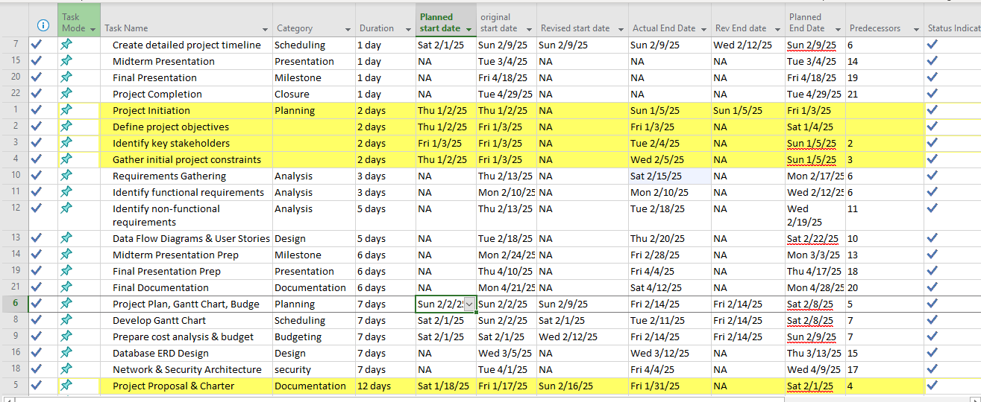

**Gantt Chart**

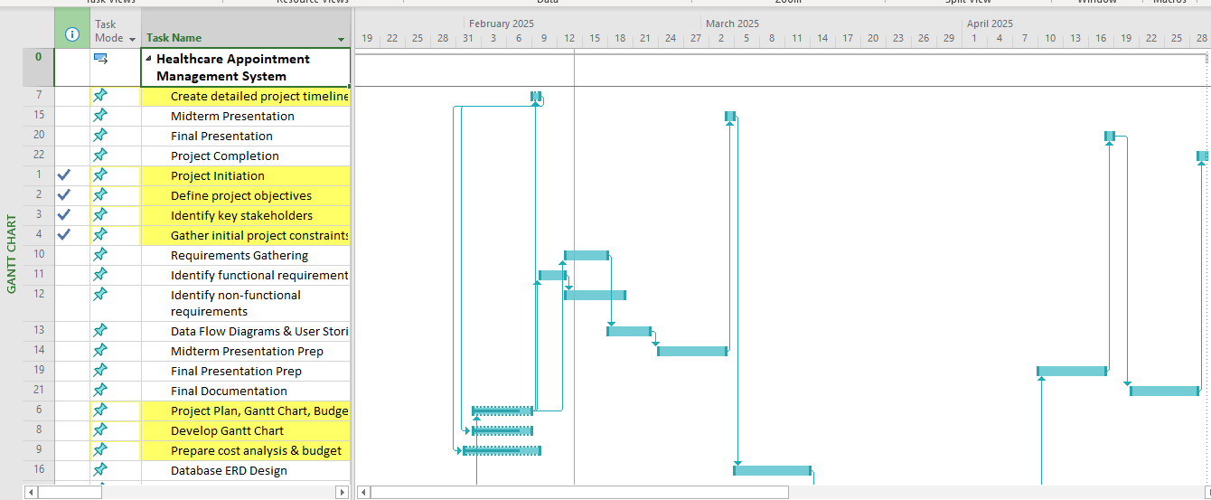

## **Project Budget**

The budget includes estimates for **hardware, software, labor, and training costs**.

### Estimated Costs

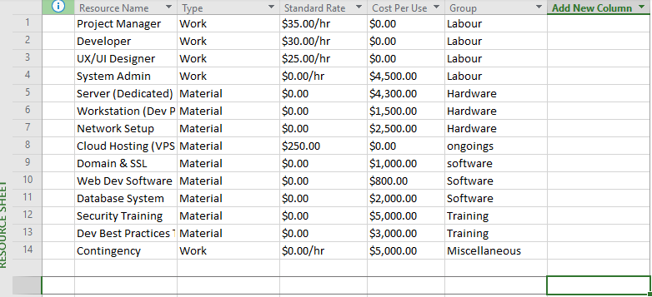

**1. Estimated Cost Breakdown**

|  |  |
| --- | --- |
| **Cost Category** | **Estimated Cost ($)** |
| Labor Costs | $35,000 |
| Hardware Costs | $12,000 |
| Software Costs | $8,000 |
| Training Costs | $3,500 |
| Operational Costs | $6,000 |
| Contingency (10%) | $5,500 |
| Total Estimated Cost | $70,000 |

### **Breakdown Explanation**

1. **Labor Costs ($35,000)**
   1. Includes salaries for project management, development, UX/UI design, system administration, and security professionals.
2. **Hardware Costs ($12,000)**
   1. Includes **dedicated servers, workstations, network setup, and backup infrastructure**.
3. **Software Costs ($8,000)**
   1. Covers licenses for **development tools, database systems, security software, and hosting services**.
4. **Training Costs ($3,500)**
   1. For **cybersecurity, development best practices, and cloud infrastructure training**.
5. **Operational Costs ($6,000)**
   1. Recurring costs like **cloud hosting, domain registration, and maintenance fees**.
6. **Contingency ($5,500)**
   1. **10%** of total cost as a buffer for unexpected expenses.

**1. Cost-Benefit Analysis**

|  |  |
| --- | --- |
| **Benefit Source** | **Estimated Annual Revenue/Cost Savings** |
| Online Sales Revenue | $30,000 |
| Reduced Manual Operations (Automated Orders) | $5,000 |
| Reduced Marketing Costs | $3,000 |
| Improved Customer Retention | $2,000 |
| Total Benefits | $40,000 |

**Total Project Cost (First Year)**

Total Estimated Costs = $70,000

**Net Benefit Calculation**

Net Benefit = Total Benefits - Total Costs

= $40,000 - $70,000 = -$30,000

**2. Payback Period Calculation**

Payback Period = Total Cost ÷ Annual Net Benefit

= $70,000 ÷ $40,000 ≈ 1.75 years (~21 months)

The payback period is 21 months, meaning the project will break even in 1.75 years.

## **3. Present Value Calculation (NPV) at 5% Discount Rate**

To assess the **long-term profitability**, the project’s future benefits are discounted using a **5% discount rate**, reflecting the time value of money.

The **Net Present Value (NPV) formula** is:

The formula NPV = ∑(Rt / (1+r)^t) is used to calculate the net present value (NPV) of an investment.

What the variables in the formula mean

1. Rt: The net cash inflow at time t
2. r: The discount rate, which reflects the time value of money and risk ((5% or 0.05))
3. t: The life of the investment

|  |  |  |  |
| --- | --- | --- | --- |
| **Year** | **Net Benefit (USD)** | **Discount Factor (5%)** | **Present Value (USD)** |
| 1 | $14,500 | 0.9524 | $13,810 |
| 2 | $20,000 | 0.9070 | $18,140 |
| 3 | $25,000 | 0.8638 | $21,595 |
| **Total** | **$59,500** |  | **$53,545** |

**NPV = $53,545**, which is **positive**, meaning the project is financially viable in the long run.

**Explanation of the Project Budget**

The project budget provides a clear financial analysis, outlining estimated costs, expected benefits, payback period, and net present value (NPV). This structured breakdown ensures that the project remains cost-effective while delivering a strong return on investment over time. The total estimated cost for the first year is $70,000, covering various aspects such as labor, hardware, software, training, operational expenses, and a contingency fund. These costs are essential for the successful development, deployment, and maintenance of the e-commerce platform.

The largest portion of the budget, $35,000, is allocated to labor costs, which include salaries for key personnel such as project managers, developers, UX/UI designers, system administrators, and security professionals. Their expertise is critical in ensuring the platform is built securely and efficiently. Hardware costs are estimated at $12,000, covering necessary infrastructure such as dedicated servers, workstations, network equipment, and backup systems, essential for reliability and data security. Software costs, totaling $8,000, account for licenses related to development tools, database management systems, security applications, and cloud hosting services. These ensure smooth platform functionality and data protection.

An additional $3,500 is allocated for training, focusing on cybersecurity, software development best practices, and cloud infrastructure management. This investment is crucial for equipping the team with the necessary skills to maintain security and operational efficiency. Operational costs, estimated at $6,000, include recurring expenses such as cloud hosting, domain registration, and system maintenance. Finally, a contingency fund of $5,500 (10% of total costs) is set aside to address unexpected expenses, ensuring financial flexibility throughout the project.

The cost-benefit analysis highlights the financial advantages expected from this investment. The platform is projected to generate $40,000 in annual benefits, including $30,000 from online sales revenue, $5,000 in savings from automated order processing, $3,000 in reduced marketing expenses, and $2,000 from improved customer retention. Despite an initial first-year cost of $70,000, these recurring benefits make the project financially sustainable in the long term.

The payback period, which measures how quickly the initial investment is recovered, is calculated as 1.75 years (or approximately 21 months). This means that after 21 months, the project will break even, and all revenue generated beyond this period will contribute to profits. This relatively short payback period indicates a strong potential for success and financial sustainability.

A Net Present Value (NPV) analysis is performed using a 5% discount rate to further evaluate long-term financial viability. The discounted cash flows over three years show a positive NPV of $53,545, confirming that the project is financially viable and beneficial in the long run. A positive NPV indicates that the project's future earnings outweigh the initial costs, making it a profitable investment.

The project is expected to recover costs within 21 months and increase revenue over time. The combination of strong annual benefits, a short payback period, and a positive NPV demonstrates the project's financial sustainability and long-term profitability. This structured budget and financial analysis provide a clear roadmap for investment, ensuring that resources are allocated efficiently while maximizing returns.

# **DFD and User Stories**

## Context Level DFD

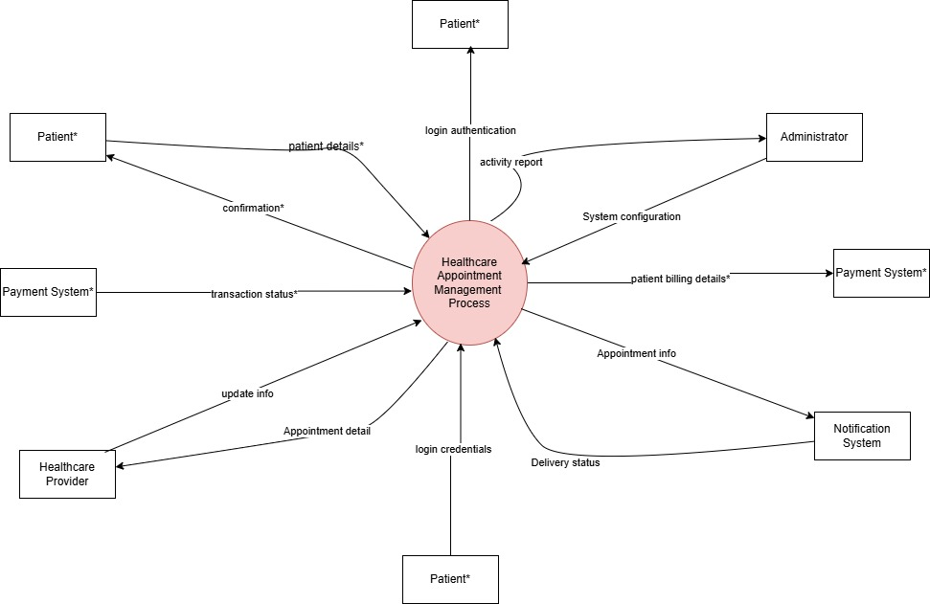

**Main Process:**

1. **Healthcare Appointment Management System (HAMS)**

**External Entities & Data Flow Descriptions:**

1. **Patient → HAMS**
   1. **Data Flow:** Appointment request (new, modify, cancel), patient details, login credentials, payment details.
   2. **Description:** The patient interacts with HAMS to schedule, modify, or cancel appointments, log in to access their account, and make payments for services.
2. **HAMS → Patient**
   1. **Data Flow:** Appointment confirmation, reminders, cancellation notices, login authentication status, payment confirmation.
   2. **Description:** HAMS sends confirmation messages for scheduled appointments, reminders, and payment receipts while validating patient login requests.
3. **Healthcare Provider → HAMS**
   1. **Data Flow:** Availability updates, appointment approvals/rejections.
   2. **Description:** Providers manage their schedules by updating available slots and confirming or canceling appointments.
4. **HAMS → Healthcare Provider**
   1. **Data Flow:** Appointment details, patient scheduling requests.
   2. **Description:** HAMS provides real-time access to patient appointments for scheduling and adjustments.
5. **Administrator → HAMS**
   1. **Data Flow:** System configuration, user management actions.
   2. **Description:** Administrators oversee scheduling processes, manage users, resolve conflicts, and monitor payment records.
6. **HAMS → Administrator**
   1. **Data Flow:** System alerts, appointment logs, activity reports, payment transaction logs.
   2. **Description:** HAMS provides system monitoring data, including user activity and financial transactions, for administrative oversight.
7. **Notification System → HAMS**
   1. **Data Flow:** Delivery status of appointment reminders.
   2. **Description:** The notification system confirms whether messages were successfully sent.
8. **HAMS → Notification System**
   1. **Data Flow:** Appointment confirmations, reminders, cancellations.
   2. **Description:** HAMS triggers notifications to inform patients and providers about appointment status.
9. **Payment System → HAMS**
   1. **Data Flow:** Payment confirmation, transaction status.
   2. **Description:** The payment system processes transactions and sends confirmation to HAMS.
10. **HAMS → Payment System**
11. **Data Flow:** Payment requests, patient billing details.
12. **Description:** HAMS sends payment requests with billing details for processing.

## Level Zero DFD

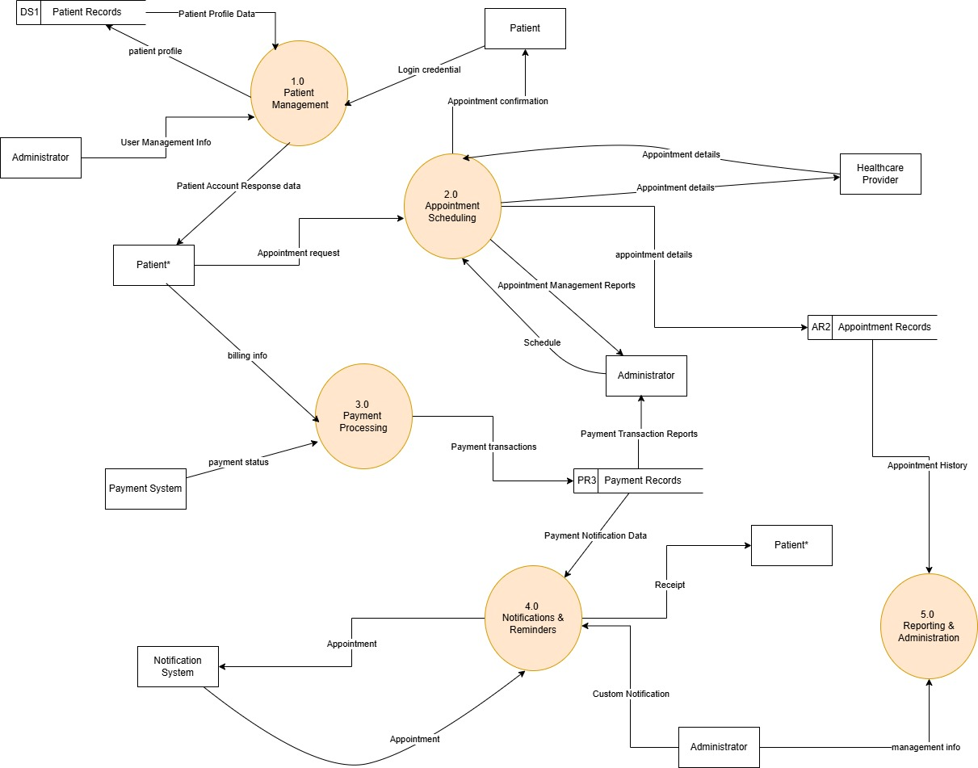

**Level 0 DFD for Healthcare Appointment Management System**

The **Level 0 Data Flow Diagram (DFD)** provides a **high-level overview** of how data flows between different entities, processes, and data stores in HAMS (Healthcare Appointment Management System). It **breaks down** the system into **five main processes** and their interactions with **external entities**: Patients**, Healthcare Providers, Administrators, and Payment Systems**. Below is a detailed breakdown of each component:

**1. External Entities and Data Stores**

* **DS1 (Patient Records)** – Stores patient profile data, including registration details, personal information, and access credentials.
* **AR2 (Appointment Records)** – Holds appointment-related data, including booking requests, schedules, and histories.
* **PR3 (Payment Records)** – Manages payment transactions, billing details, and financial logs.
* **Notification System** – Handles automated notifications related to appointments and payments.
* **Payment System** – Processes patient payments and updates payment statuses.
* **Administrator** – Manages system configurations, access control, and reporting functionalities.
* **Healthcare Provider** – Receives and manages appointment details for patients.

**2. Main Processes in the Level 0 DFD**

**1.0 Patient Management**

This process is responsible for handling patient **registration, authentication, profile management, and access control**.

1. **Input:**
   1. Patients provide **registration details** and **login credentials**.
   2. Administrators provide **user management data**.
2. **Output:**
   1. Patient profiles are stored in **DS1 (Patient Records)**.
   2. Authentication status is provided to **patients**.
   3. User management responses are sent back to **administrators**.

**2.0 Appointment Scheduling**

Handles **appointment requests, scheduling, confirmations, and modifications** between patients and healthcare providers.

1. **Input:**
   1. Patients submit **appointment requests**.
   2. Healthcare providers provide **availability details**.
   3. Administrators manage **appointment records**.
2. **Output:**
   1. Appointment details are stored in **AR2 (Appointment Records)**.
   2. Patients receive **confirmation updates**.
   3. Healthcare providers get **appointment schedules**.

**3.0 Payment Processing**

Manages **billing, payment transactions, and payment verification**.

1. **Input:**
   1. Patients provide **billing information**.
   2. The Payment System processes **transactions**.
2. **Output:**
   1. Payment transactions are recorded in **PR3 (Payment Records)**.
   2. Payment status is sent back to **patients**.
   3. Administrators receive **payment reports**.

**4.0 Notifications & Reminders**

Handles **automated notifications** for appointments, payments, and other system alerts.

1. **Input:**
   1. Appointment details from **AR2 (Appointment Records)**.
   2. Payment status from **PR3 (Payment Records)**.
   3. Custom notifications from **Administrators**.
2. **Output:**
   1. Appointment reminders are sent to **patients** and **healthcare providers**.
   2. Payment status notifications are sent to **patients**.

**5.0 Reporting & Administration**

Handles **report generation, system monitoring, and administrative management**.

1. **Input:**
   1. System data from **DS1 (Patient Records)**, **AR2 (Appointment Records)**, and **PR3 (Payment Records)**.
   2. Administrator inputs for **system updates and configurations**.
2. **Output:**
   1. Reports on **appointments, payments, and user activities** are provided to **administrators**.
   2. Management information is updated in the system.

**3. Data Flow Summary**

* **Patients interact with** the system via **Patient Management (1.0)** and **Appointment Scheduling (2.0)**.
* **Appointments are scheduled, confirmed, or modified** through **Appointment Scheduling (2.0)** and stored in **AR2**.
* **Payments are processed** through **Payment Processing (3.0)** and stored in **PR3**.
* **Notifications and reminders are sent** via **Notifications & Reminders (4.0)** to patients and healthcare providers.
* **Administrators manage system functions and generate reports** using **Reporting & Administration (5.0)**.

## **Level One DFD**

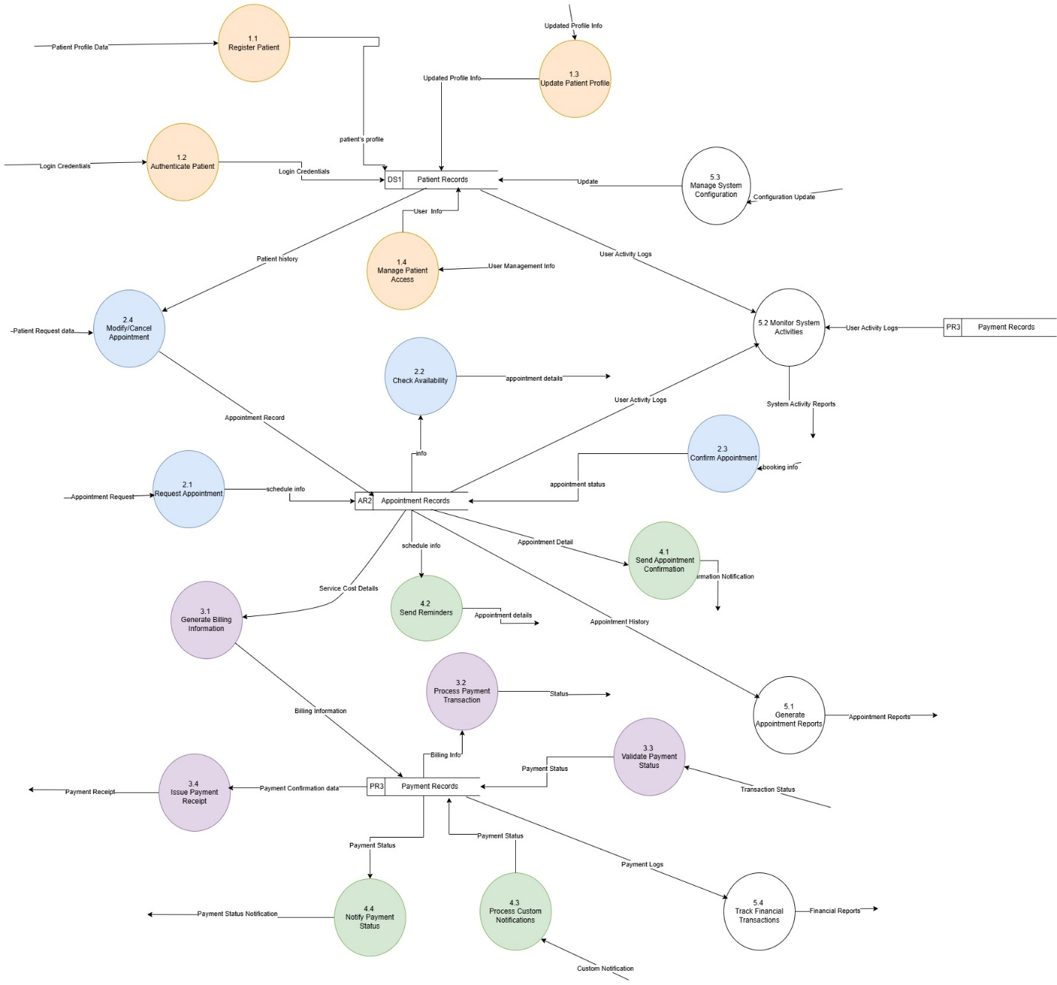

**Level 1 Data Flow Diagram (DFD) for the Healthcare Appointment Management System**

The **Level 1 DFD** decomposes the high-level processes of **Level 0 DFD** into **specific sub-processes**, showing how data flows between external entities, processes, and data stores. Each of the **five major functional areas** of the system is broken down into its core sub-processes.

**1.0 Patient Management**

This section handles **patient registration, authentication, profile updates, and account access control**.

* **1.1 Register Patient:**
  + A new patient provides **profile data** (name, contact, etc.).
  + The system **stores the information in the Patient Records (DS1)**.
* **1.2 Authenticate Patient:**
  + When patients log in, their **credentials** are checked against **DS1 (Patient Records)**.
  + If verified, access is granted; otherwise, an error message is returned.
* **1.3 Update Patient Profile:**
  + Patients can modify personal details (address, phone number, etc.).
  + Updated profile info is saved back to **DS1 (Patient Records)**.
* **1.4 Manage Patient Access:**
  + The **administrator** manages access levels and permissions.
  + The system logs user activities and updates **DS1** for authentication and authorization.

**2.0 Appointment Scheduling**

This section deals with **booking, modifying, and confirming appointments**.

* **2.1 Request Appointment:**
  + A patient submits an **appointment request** (preferred date/time).
  + The system logs the request into **AR2 (Appointment Records)**.
* **2.2 Check Availability:**
  + The system checks if the healthcare provider is available on the requested date.
  + Appointment details are retrieved from **AR2 (Appointment Records)** and provided to the patient.
* **2.3 Confirm Appointment:**
  + If available, the healthcare provider confirms the appointment.
  + The **updated status is stored in AR2** and sent to the notification system.
* **2.4 Modify/Cancel Appointment:**
  + Patients or providers can modify or cancel appointments.
  + The new status is **updated in AR2**.
* **2.5 Notify Healthcare Provider:**
  + Once an appointment is scheduled or modified, a **notification with details is sent to the provider**.

**3.0 Payment Processing**

This section **manages billing and payment transactions** for appointments.

* **3.1 Generate Billing Information:**
  + Based on the confirmed appointment, the system **generates an invoice**.
  + The billing details are stored in **PR3 (Payment Records)**.
* **3.2 Process Payment Transaction:**
  + The patient submits payment details (credit card, insurance, etc.).
  + The system sends the payment request to the **external Payment System**.
* **3.3 Validate Payment Status:**
  + The **Payment System** confirms whether the payment was successful.
  + If successful, the **status is updated in PR3 (Payment Records)**.
* **3.4 Issue Payment Receipt:**
  + A **payment confirmation is sent to the patient** upon successful transaction.

**4.0 Notifications & Reminders**

This section ensures patients and healthcare providers **receive important alerts and updates**.

* **4.1 Send Appointment Confirmation:**
  + Once an appointment is booked, the system **sends confirmation** to the patient.
* **4.2 Send Reminders:**
  + Patients are **notified of upcoming appointments** (via email/SMS).
* **4.3 Process Custom Notifications:**
  + The **administrator** can send custom notifications for updates or urgent messages.
* **4.4 Notify Payment Status:**
  + The system informs patients about **payment success or failure**.

**5.0 Reporting & Administration**

This section allows administrators to **monitor activities, generate reports, and manage system settings**.

* **5.1 Generate Appointment Reports:**
  + The system retrieves **appointment history from AR2** and generates reports for analytics.
* **5.2 Monitor System Activities:**
  + The administrator **tracks user activity logs from DS1, AR2, and PR3** for security and audits.
* **5.3 Manage System Configuration:**
  + The administrator **modifies system settings**, and updates are applied across processes.
* **5.4 Track Financial Transactions:**
  + Financial transactions from **PR3 (Payment Records)** are analyzed for audits.

**Key Data Stores & Entities**

**Patient Records (DS1)** → Stores patient profiles and login details.

**Appointment Records (AR2)** → Stores all appointment-related data.

**Payment Records (PR3)** → Logs financial transactions.

**External Entities:**

* 1. **Patient** → Registers, books appointments, make payments.
  2. **Healthcare Provider** → Manages appointments and schedules.
  3. **Administrator** → Oversees the system and generates reports.
  4. **Payment System** → Processes financial transactions.
  5. **Notification System** → Sends alerts and reminders.

**User Stories for Healthcare Appointment Management System (HAMS)**

**1. Patient User Stories**

* As a patient, I want to register my account so that I can book an appointment.
* As a patient, I want to log in securely so that I can access my appointment history and profile.
* As a patient, I want to update my profile information so that I can keep my contact details current.
* As a patient, I want to search for available appointment slots so that I can choose a convenient time.
* As a patient, I want to request an appointment so that I can receive medical consultation.
* As a patient, I want to receive a confirmation after booking an appointment so that I know my request is successful.
* As a patient, I want to reschedule an appointment so that I can change the date if necessary.
* As a patient, I want to cancel an appointment so that I don’t get charged for a visit I can’t attend.
* As a patient, I want to receive reminders for my upcoming appointments so that I don’t miss them.
* As a patient, I want to view my appointment history so that I can track my past medical visits.
* As a patient, I want to view the cost of services before booking so that I can plan my expenses.
* As a patient, I want to make a payment for my appointment online so that I can confirm my booking.
* As a patient, I want to receive a payment receipt so that I have proof of payment.
* As a patient, I want to receive notifications about my payment status so that I know if my transaction is successful.
* As a patient, I want to receive updates about my appointment status so that I know if the doctor is available.

**2. Healthcare Provider User Stories**

* As a healthcare provider, I want to log in securely so that I can access patient appointments.
* As a healthcare provider, I want to view upcoming appointments so that I can prepare for patient visits.
* As a healthcare provider, I want to update my availability so that patients can schedule appointments accordingly.
* As a healthcare provider, I want to confirm an appointment request so that I can approve or decline bookings.
* As a healthcare provider, I want to reschedule an appointment for a patient so that I can adjust my schedule.
* As a healthcare provider, I want to cancel an appointment if needed so that I can notify the patient in advance.
* As a healthcare provider, I want to send custom notifications to patients so that I can inform them of urgent updates.
* As a healthcare provider, I want to track the history of past appointments so that I can review patient records.
* As a healthcare provider, I want to receive payment confirmations to know if the patient has paid.
* As a healthcare provider, I want to access financial reports so that I can track earnings from appointments.

**3. Administrator User Stories**

* As an administrator, I want to manage user accounts so that I can control system access.
* As an administrator, I want to monitor system activity logs so that I can track suspicious behavior.
* As an administrator, I want to generate appointment reports so that I can analyze patient visit trends.
* As an administrator, I want to manage system configuration settings so that I can update the platform.
* As an administrator, I want to oversee financial transactions so that I can track revenue.
* As an administrator, I want to validate payment statuses so that I can confirm completed transactions.
* As an administrator, I want to issue payment receipts so that patients receive proof of their transactions.
* As an administrator, I want to send bulk notifications to users so that I can update them about system changes.
* As an administrator, I want to audit canceled appointments so that I can understand cancellation trends.

**4. Notification System User Stories**

As a system, I want to send appointment confirmations so that patients know their booking status.

As a system, I want to send appointment reminders so that patients don’t miss their visits.

As a system, I want to notify patients of payment status updates so that they can take necessary action.

As a system, I want to notify healthcare providers of schedule changes so that they stay informed.

As a system, I want to log all notifications so that administrators can track communication history.

# Database Design with ERD

**First Normalization**

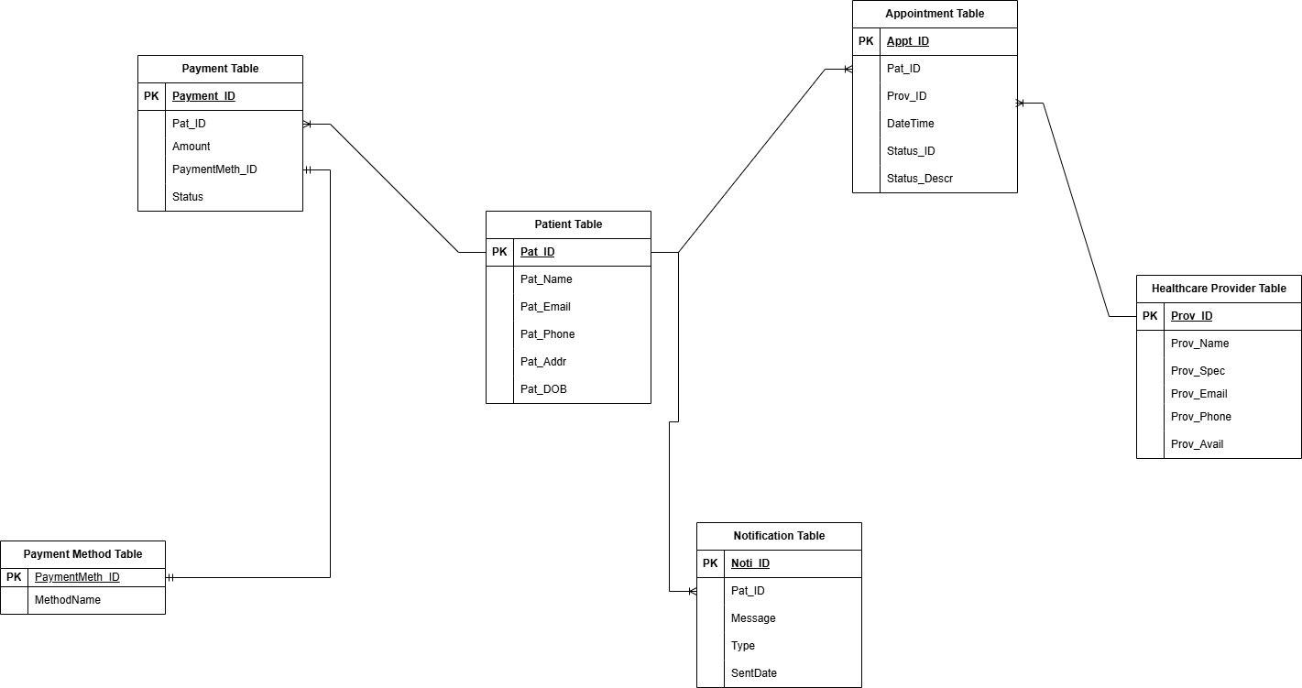

**Second Normalization**

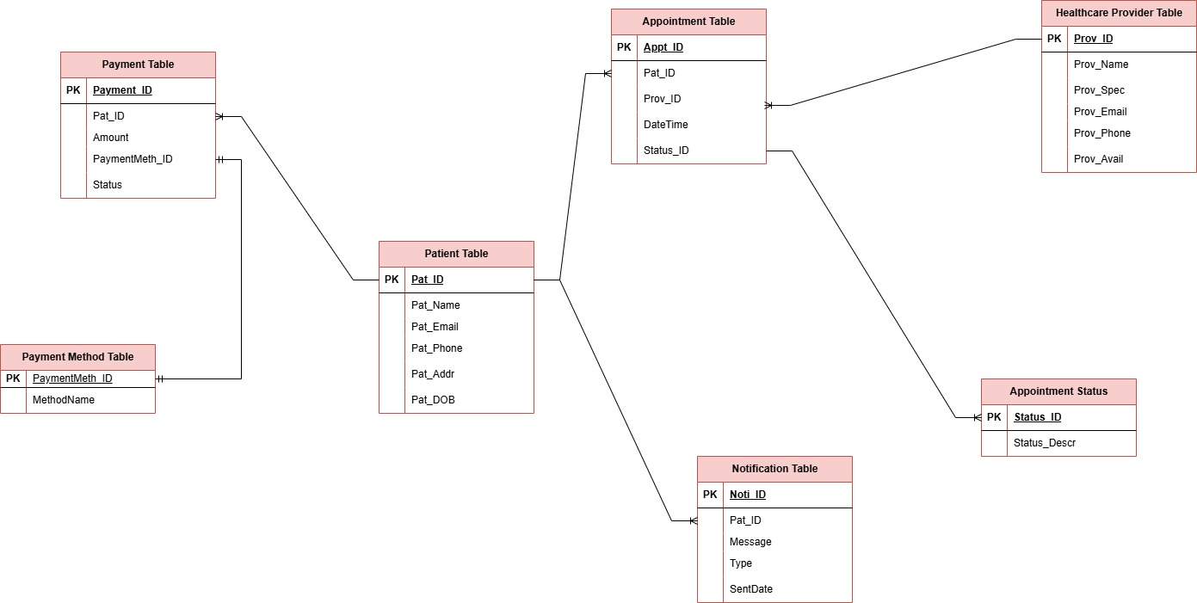

**Third Normalization**

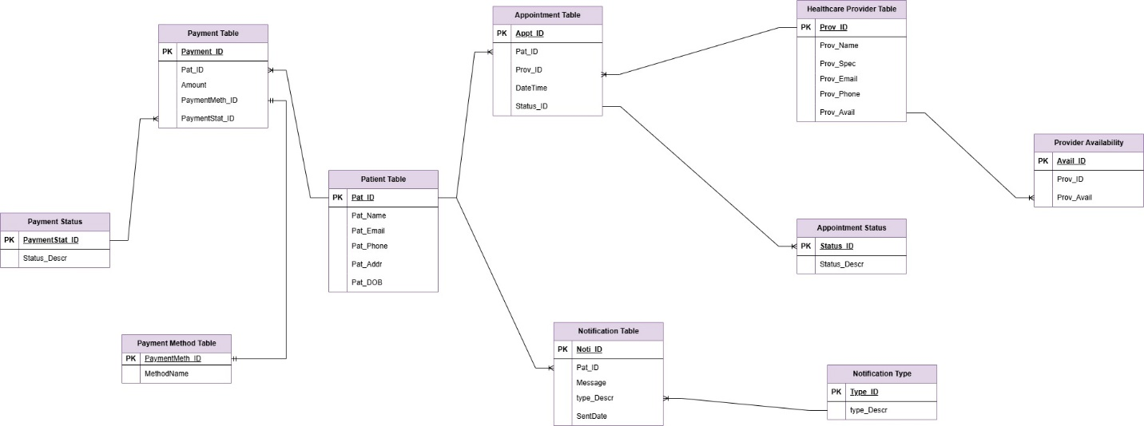

**Crow’s foot notation**

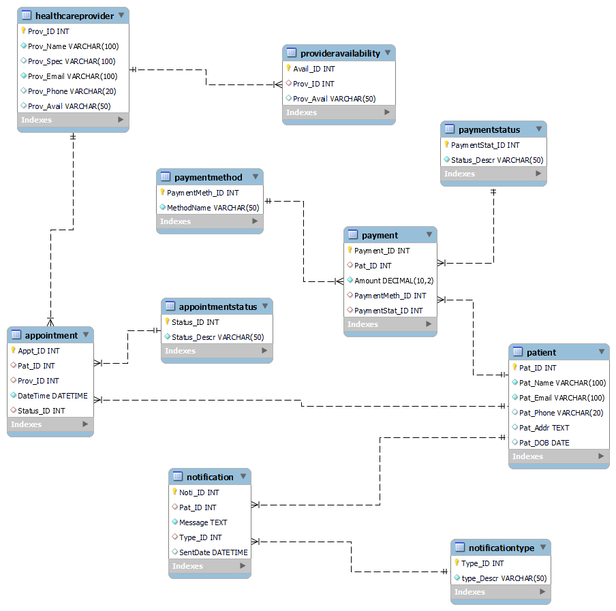

**1. Patient Table**

1. **Purpose:** Stores information about patients.
2. **Attributes:**
   1. Pat_ID: Primary Key (Unique Identifier for each patient).
   2. Pat_Name: Name of the patient.
   3. Pat_Email: Unique email for communication.
   4. Pat_Phone: Contact number.
   5. Pat_Addr: Address.
   6. Pat_DOB: Date of birth.

**Relationships:**

1. A patient can have multiple **appointments** (Appointment table).
2. A patient can make multiple **payments** (Payment table).
3. A patient can receive multiple **notifications** (Notification table).

**2. Healthcare Provider Table**

1. **Purpose:** Stores healthcare provider (doctor/nurse) details.
2. **Attributes:**
   1. Prov_ID: Primary Key (Unique Identifier for each provider).
   2. Prov_Name: Name of the healthcare provider.
   3. Prov_Spec: Specialization (e.g., Cardiologist, Dentist).
   4. Prov_Email: Unique email.
   5. Prov_Phone: Contact number.
   6. Prov_Avail: Availability (time slots).

**Relationships:**

1. A provider can have multiple **appointments** (Appointment table).
2. Provider availability is managed in the ProviderAvailability table.

**3. AppointmentStatus Table**

1. **Purpose:** Defines different statuses for appointments (e.g., **Scheduled, Canceled, Completed**).
2. **Attributes:**
   1. Status_ID: Primary Key (Unique Identifier for each status).
   2. Status_Descr: Description of the status.

**Relationships:**

1. Linked to the Appointment table to track an appointment’s current status.

**4. Appointment Table**

1. **Purpose:** Stores appointment details between patients and healthcare providers.
2. **Attributes:**
   1. Appt_ID: Primary Key (Unique identifier for each appointment).
   2. Pat_ID: Foreign Key (References Patient.Pat_ID).
   3. Prov_ID: Foreign Key (References HealthcareProvider.Prov_ID).
   4. DateTime: Scheduled date and time.
   5. Status_ID: Foreign Key (References AppointmentStatus.Status_ID).

**Relationships:**

1. An appointment is associated with one **patient**.
2. An appointment is assigned to one **provider**.
3. An appointment has one **status**.

**Constraints:**

1. **ON DELETE CASCADE** for Pat_ID and Prov_ID ensures that if a patient or provider is deleted, their related appointments are also deleted.
2. **ON DELETE SET NULL** for Status_ID ensures that if a status is removed, appointments retain the record with a NULL status.

**5. ProviderAvailability Table**

* **Purpose:** Manages provider availability for appointments.
* **Attributes:**
  + Avail_ID: Primary Key.
  + Prov_ID: Foreign Key (References HealthcareProvider.Prov_ID).
  + Prov_Avail: Time slots available.

**Relationships:**

* Each provider has an availability schedule.

**Constraints:**

* **ON DELETE CASCADE** ensures that their availability records are also deleted when a provider is removed.

**6. Payment Method Table**

* **Purpose:** Stores use different payment methods (e.g., **credit card, cash, insurance**).
* **Attributes:**
  + PaymentMeth_ID: Primary Key.
  + MethodName: Name of the payment method.

**Relationships:**

* Linked to the Payment table to specify how a patient made a payment.

**7. Payment Status Table**

* **Purpose:** Stores different payment statuses (e.g., **Pending, Completed, Failed**).
* **Attributes:**
  + PaymentStat_ID: Primary Key.
  + Status_Descr: Description of the payment status.

**Relationships:**

1. Linked to the Payment table to track payment progress.

**8. Payment Table**

1. **Purpose:** Stores records of patient payments.
2. **Attributes:**
   1. Payment_ID: Primary Key.
   2. Pat_ID: Foreign Key (References Patient.Pat_ID).
   3. Amount: Payment amount.
   4. PaymentMeth_ID: Foreign Key (References PaymentMethod.PaymentMeth_ID).
   5. PaymentStat_ID: Foreign Key (References PaymentStatus.PaymentStat_ID).

**Relationships:**

1. Each payment belongs to **one patient**.
2. Each payment has a **payment method**.
3. Each payment has a **status**.

**Constraints:**

1. **ON DELETE CASCADE** for Pat_ID ensures that if a patient is deleted, their payment records are also deleted.
2. **ON DELETE SET NULL** for PaymentMeth_ID and PaymentStat_ID ensures that if a payment method or status is deleted, payments remain but with NULL values.

**9. NotificationType Table**

* **Purpose:** Defines different types of notifications (e.g., **Appointment Reminder, Payment Due, General Alert**).
* **Attributes:**
  + Type_ID: Primary Key.
  + Type_Descr: Description of the notification type.

**10. Notification Table**

* **Purpose:** Stores notifications sent to patients.
* **Attributes:**
  + Noti_ID: Primary Key.
  + Pat_ID: Foreign Key (References Patient.Pat_ID).
  + Message: Notification message.
  + Type_ID: Foreign Key (References NotificationType.Type_ID).
  + SentDate: Timestamp (default is current time).

**Relationships:**

* Each notification is sent to **one patient**.
* Each notification has a **notification type**.

**Constraints:**

* **ON DELETE CASCADE** for Pat_ID ensures that if a patient is deleted, their notifications are also deleted.
* **ON DELETE SET NULL** for Type_ID ensures that notifications remain with a NULL type if a notification type is removed.

**Summary of Relationships in ERD**

1. **One-to-Many Relationships:**
   1. **A patient can have multiple appointments** but each appointment is linked to only **one patient**.
   2. **A healthcare provider can have multiple appointments** but each appointment is linked to only **one provider**.
   3. **A patient can make multiple payments**, but each payment belongs to only **one patient**.
   4. **A patient can receive multiple notifications**, but each notification is linked to only **one patient**.
   5. **A payment method/status can be linked to multiple payments**, but each payment has only **one method/status**.
2. **Many-to-One Relationships:**
   1. **Each appointment has one status** (but one status can be assigned to multiple appointments).
   2. **Each payment has one status and one method** (but a status/method can apply to multiple payments).
   3. **Each notification has one type** (but a type can be linked to multiple notifications).
3. **Constraints and Actions:**
   1. **ON DELETE CASCADE**: If a patient/provider is deleted, their related records (appointments, payments, notifications) are also deleted.
   2. **ON DELETE SET NULL**: If a status or method is deleted, existing records retain NULL values

# **Network Design and Security**

**Network design**

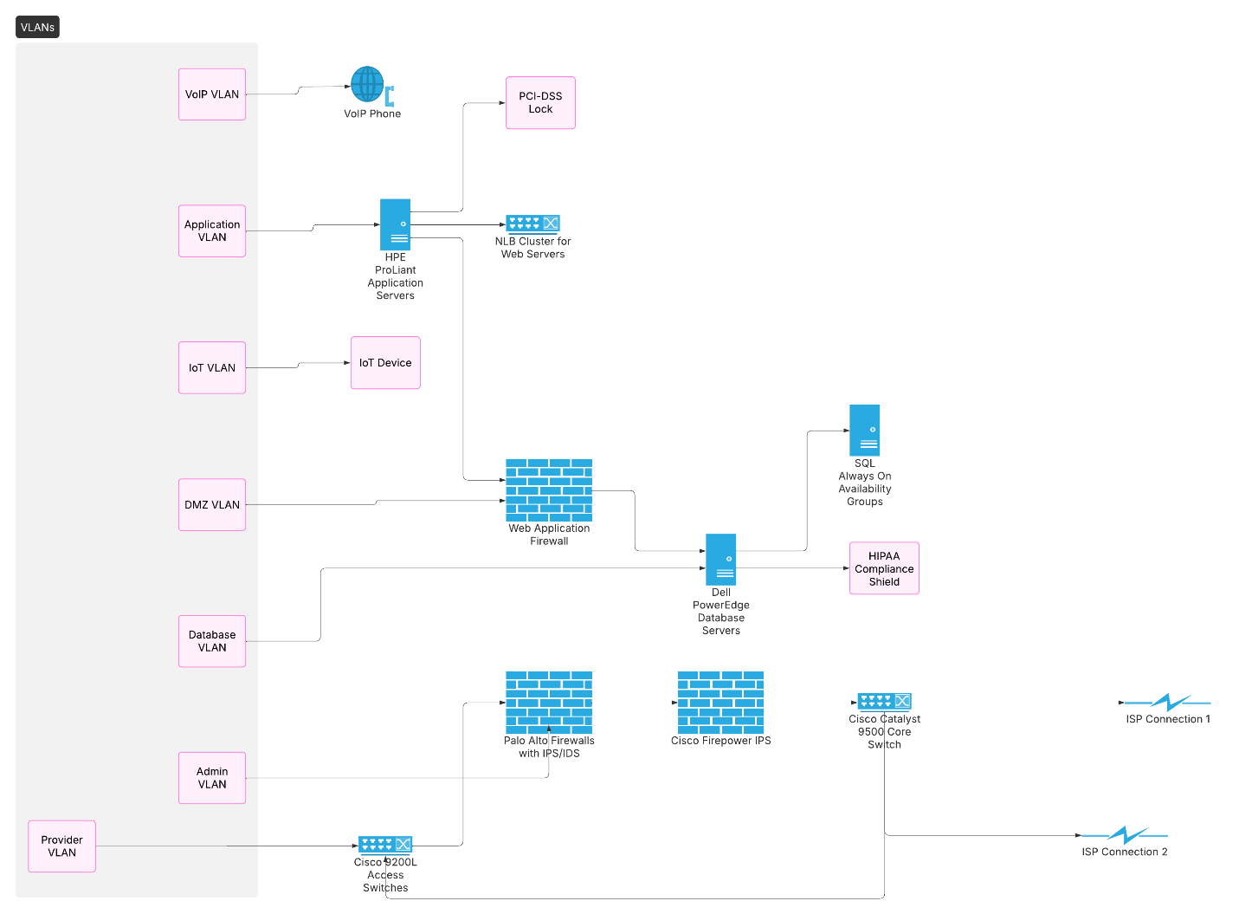

**Network Diagram Key Explanation**

1. **VLAN Segmentation**
   1. **VoIP VLAN**: Dedicated network for voice communications (phone systems)
   2. **Application VLAN**: Hosts appointment scheduling and payment processing systems
   3. **Database VLAN**: Isolated zone for sensitive patient records (HIPAA protected)
   4. **Admin VLAN**: Restricted access for IT administrators
   5. **Provider VLAN**: Secure area for healthcare provider workstations

**Security Components**

* 1. **Firewalls** (VoIP/Applications):
     1. Enforce access control between network segments
     2. VoIP firewall specifically protects voice communication systems
  2. **PCI-DSS Lock**: Indicates payment processing areas with credit card security compliance
  3. **HPAA Compliance Sheds**: Physical/network protections for HIPAA-regulated data

1. **Authentication Systems**
   1. **RDD Authentication**: Robust device authentication for database access
   2. **IP/PDX**: Secure protocol for internal communications
2. **Specialized Hardware**
   1. **FireLIGHT Application Server™**: Security-focused server for processing healthcare applications
   2. **Cisco Transport Cards**: High-security network interface cards for data transmission
   3. **IGT Devices**: Medical IoT equipment with dedicated network segment
3. **Compliance Markers**
   1. **HDIA Compliance**: Health Data Interoperability Assurance standards
   2. **General PROM-1**: Patient Record Oversight Management protocol
   3. **Accident Certificate**: Emergency access certification system
4. **Network Connections**
   1. **IP Connection 1/2**: Redundant internet links with automatic failover
   2. **IGP Connection**: Interior Gateway Protocol for routing between VLANs

**Network Architecture and Security Design for Healthcare Appointment Management System (HAMS)**

**Introduction**

The Healthcare Appointment Management System (HAMS) represents a critical digital infrastructure that requires meticulous network planning and robust security measures. This is an overview of the comprehensive network architecture specifically designed to support HAMS operations while ensuring the highest levels of data protection, system availability, and regulatory compliance.

At its core, network architecture must balance three competing priorities: enabling seamless appointment scheduling and management for thousands of users, protecting highly sensitive patient health information, and maintaining continuous system availability that healthcare operations demand. The solution developed in this architecture addresses these needs through a multi-layered approach that combines physical infrastructure, logical segmentation, comprehensive security controls, and redundancy measures - all while meeting strict HIPAA and PCI-DSS compliance requirements for healthcare data and payment processing respectively.

**Network Architecture Foundation**

The HAMS network architecture follows a structured tiered model that mirrors the system's functional layers while implementing defense-in-depth security principles. This begins with the physical infrastructure foundation that hosts all system components in an on-premises data center environment designed for high availability. The data center utilizes enterprise-grade Dell PowerEdge R750xa servers for database operations, configured with dual 32-core processors, 256GB of RAM, and RAID-10 SSD storage arrays to ensure optimal performance for the SQL databases that store all patient, provider, appointment, and payment records as defined in the ERD.

Complementing these database servers are HPE ProLiant DL380 application servers that handle the core business logic of the system - processing appointment scheduling requests (DFD Process 2.0), managing payment transactions (DFD Process 3.0), and coordinating notification services (DFD Process 4.0). These servers connect through a high-speed 40Gbps backbone built on Cisco Catalyst 9500-48Y4C core switches that provide VXLAN capability for flexible network segmentation and NetFlow monitoring for comprehensive traffic analysis. The access layer utilizes Cisco Catalyst 9200L switches with 48-port PoE+ configurations to support various endpoints while implementing port security and DHCP snooping to prevent unauthorized network access.

At each healthcare facility location, the network extends with purpose-built segments for different user groups and functions. Wired infrastructure separates provider workstations (needing access to Prov_ID records), administrative staff (requiring user management capabilities), and medical IoT devices onto distinct VLANs. Wireless access deploys Cisco 9100 Access Points with WPA3-Enterprise authentication, creating separate SSIDs for staff and guests while implementing band steering and airtime fairness features to optimize the user experience for appointment scheduling via mobile devices.

**Logical Network Design and Segmentation**

The logical network design implements rigorous segmentation based on both functional requirements from the DFD and data sensitivity levels from the ERD. This segmentation occurs primarily through VLAN implementation with strict access controls between segments:

The Database Tier (VLAN 10) forms the most protected zone, hosting all SQL servers that contain sensitive patient records (Pat_ID, Pat_Name, Pat_DOB), appointment data (Appt_ID, DateTime), and payment information (Payment_ID, Amount). Access to this tier is tightly restricted, only permitting connections from application servers on specific ports (1433 for SQL Server, 1521 for Oracle) and allowing database administrators access solely through secured jump hosts.

The Application Tier (VLAN 20) contains the business logic servers that process appointment scheduling, payments, and notifications. These servers are permitted to communicate with web servers in the DMZ (ports 443 and 8443) while maintaining exclusive database connectivity. This middle layer ensures proper isolation between the presentation interfaces and sensitive data stores.

The DMZ (VLAN 30) hosts all patient-facing components including web portals (from screen maps), API gateways, and reverse proxies. This perimeter network implements additional security measures like Web Application Firewalls (WAF), DDoS protection systems, and rate limiting to safeguard against internet-borne threats while maintaining accessibility for legitimate users.

IP addressing follows RFC 1918 standards with hierarchical allocation using the 10.10.0.0/16 private space. The database tier occupies 10.10.10.0/24, application servers use 10.10.20.0/24, and the DMZ resides on 10.10.30.0/24. Administrative functions are allocated to 10.10.40.0/24 while provider workstations use 10.10.50.0/24. A secondary 172.16.0.0/12 range stands ready for failover scenarios, ensuring continuous operation during network reconfiguration events.

**Comprehensive Security Implementation**

Perimeter security begins with Palo Alto PA-5200 series next-generation firewalls positioned at the internet edge. These firewalls implement application-aware filtering, user identity integration with Active Directory, and advanced threat prevention services. Rules are meticulously configured to only allow necessary traffic - HTTPS (443) to the patient portal, SMTP (587) for encrypted notification delivery, and VPN (443) for remote administrative access.

Behind the firewalls, Cisco Firepower 4140 Intrusion Prevention Systems provide deep packet inspection with custom rules tailored to healthcare traffic patterns. These systems specifically guard against SQL injection attempts targeting patient databases while employing behavioral analysis to detect anomalies in appointment booking patterns that might indicate fraudulent activity.

Data protection employs multiple encryption strategies appropriate to different states and sensitivity levels. In transit, TLS 1.3 with AES-256-GCM encryption secures all web traffic while IPSec protects site-to-site VPN connections. At rest, Transparent Data Encryption (TDE) safeguards SQL databases, LUKS encrypts Linux servers, and BitLocker secures Windows systems. Special protection applies to particularly sensitive fields - Pat_DOB receives field-level encryption to meet HIPAA requirements while payment card data is encrypted following PCI-DSS standards using a validated P2PE solution.

Access control follows both Role-Based Access Control (RBAC) aligned with screen map interfaces and Attribute-Based Access Control (ABAC) for contextual restrictions. Patients can read/write their own appointments (Appt_ID), providers manage their schedules (Prov_Avail), while admins have full user management capabilities. ABAC policies enforce time-based restrictions (blocking after-hours access) and location-based controls (limiting sensitive functions to facility IP ranges).

Identity and authentication services leverage Microsoft Active Directory with tiered authentication methods - smart cards for admin access, certificates for providers, and multi-factor authentication (MFA) for all remote connections. RADIUS servers handle network device administration and wireless authentication, while CyberArk manages privileged access through credential rotation, session recording, and just-in-time elevation to minimize insider threat risks.

**Network Services and High Availability**

The DNS architecture implements internal Windows DNS servers with split-horizon configuration, DNSSEC validation, and comprehensive query logging. These maintain records for critical systems like hams-db01.internal, hams-app01.internal, and hams-web01.internal. External DNS utilizes Cloudflare with CAA records to restrict certificate authorities, DMARC/DKIM/SPF for email security, and always-on monitoring.

DHCP services provide carefully configured scopes - provider workstations (10.10.50.100-200), admin workstations (10.10.40.100-150), with reservations for network devices, servers, and printers. Security features include DHCP snooping on all access switches, IP source guard to prevent address spoofing, and dynamic ARP inspection to mitigate man-in-the-middle attacks.

High availability design ensures the 99.99% uptime required for critical healthcare operations. The database tier implements SQL Server Always on Availability Groups with synchronous commit for zero data loss, automatic failover, and read-only replicas for reporting. Application servers configure NLB clusters with health monitoring, automatic load redistribution, and sticky sessions to maintain appointment booking continuity.

Network redundancy employs Stackwise Virtual technology on Cisco switches with equal-cost multipathing (ECMP) for optimal routing and Bidirectional Forwarding Detection (BFD) for rapid failure detection. Internet connectivity maintains dual ISP links with BGP routing for automatic failover within 30 seconds of disruption, using physically diverse paths to prevent single points of failure.

**Monitoring, Management, and Compliance**

Network monitoring utilizes SolarWinds NPM to track interface utilization, server resources, and application response times with threshold alerts for CPU, bandwidth, and storage capacity. Security monitoring employs Splunk SIEM to correlate firewall logs, Windows events, and database audit trails, detecting brute force attempts, unusual data access patterns, and after-hours activity.

Configuration management follows Infrastructure as Code principles using Ansible playbooks for switch configurations, firewall rule updates, and server hardening. Change control requires ServiceNow tickets, peer review, and security team approval for all modifications, with automated backups preserving network device configs and server states.

HIPAA technical safeguards are fully implemented including unique user IDs, automatic 15-minute logoff, and encryption for all ePHI. Audit controls log all access to patient records, appointment modifications, and payment transactions with 6-year retention. Integrity controls apply digital signatures to appointment confirmations and payment receipts while verifying database backup hashes.

PCI-DSS requirements are met through isolated payment processing segments with restricted access to Payment_ID records and cardholder data, validated by quarterly segmentation checks. Encryption follows P2PE standards for payment terminals with key management employing dual control, split knowledge, and quarterly rotation.

**Disaster Recovery and Implementation**

The backup strategy implements Veeam solutions with 15-minute RPO for transaction logs, daily full backups, and weekly synthetic full stored on-site, in the cloud, and on air-gapped tapes. Configuration backups export network device configs, server states, and application settings daily with versioned 30-day retention.

Recovery procedures prioritize patient appointment databases and active provider schedules (Tier 1, 0-4 hour RTO) followed by historical records and reporting systems (Tier 2, 4-24 hour RTO). Quarterly disaster recovery drills test database restoration, failover processes, and staff notification procedures.

This comprehensive network architecture provides HAMS with a secure, high-performance foundation that specifically addresses healthcare appointment management requirements while meeting stringent regulatory obligations. By carefully aligning technical implementation with system documentation - protecting ERD entities, supporting DFD processes, and enabling screen map interfaces - the design achieves an optimal balance between security, availability, and usability. Regular reviews and updates will ensure the network evolves alongside emerging threats and changing business needs, maintaining its effectiveness as a critical healthcare infrastructure component.

# Application Design

* **Screen maps**

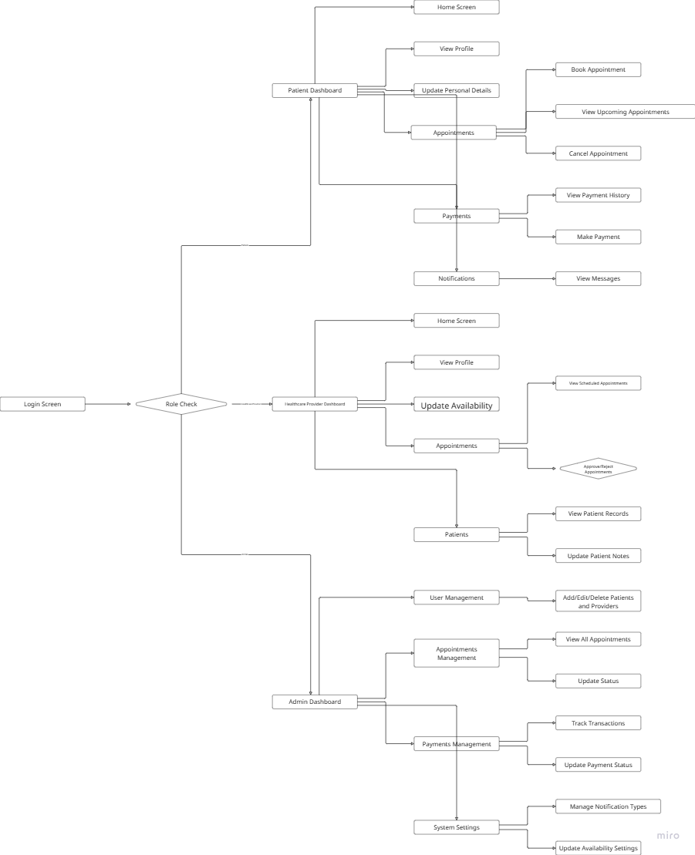

**1. Login Process & Role-Based Access**

**Login Screen:**

* **Entry Point:** All users start at the Login Screen, where they enter their credentials (username and password) to access the system.
* **Authentication:** The system verifies the credentials to ensure the user is authorized to access the application.

**Role Check Decision:**

**Role Determination:** After successful authentication, the system checks the user's role (Patient, Healthcare Provider, or Admin).

**Dashboard Routing:** Based on the role, the user is directed to the appropriate dashboard:

* 1. **Patient Dashboard:** For users who book and manage healthcare appointments.
  2. **Healthcare Provider Dashboard:** For doctors or medical professionals managing their schedules and patient records.
  3. **Admin Dashboard:** This is for system administrators who manage users, appointments, payments, and settings.

**2. Patient Dashboard**

**Home Screen:**

1. **Main Hub:** The Home Screen is where patients can view their activities, such as upcoming appointments and notifications.

**View Profile:**

* **Profile Access:** Patients can view their details, including contact information and medical history.

**Update Personal Details:**

* **Information Modification:** Patients can update or modify their personal information, such as address, phone number, or insurance details.

**Appointments Management:**

* **Book Appointment:** Patients can schedule new appointments with healthcare providers.
* **View Upcoming Appointments:** Displays a list of all future appointments that the patient has scheduled.
* **Cancel Appointment:** Allows patients to cancel any scheduled appointments if needed.

**Payments:**

* **View Payment History:** Patients can review their past transactions, including payments made for healthcare services.
* **Make Payment:** Enables patients to pay for healthcare services, either for upcoming appointments or outstanding balances.

**Notifications:**

* **View Messages:** Patients can receive and check notifications related to their appointments, payments, and other important updates.

**3. Healthcare Provider Dashboard**

**Home Screen:**

* **Overview:** The Home Screen provides healthcare providers with an overview of their upcoming appointments and any relevant notifications.

**View Profile:**

* **Profile Access:** Providers can view and update their personal and professional details, such as contact information and specialties.

**Appointments Management:**

* **View Scheduled Appointments:** Providers can see a list of all their upcoming appointments.
* **Update Availability:** Providers can set or modify their available time slots for appointments, ensuring they can manage their schedules effectively.

**Patients Section:**

* **View Patient Records:** Providers can access the medical history and records of their patients.
* **Update Patient Notes:** Providers can add or update notes related to a patient's medical history, treatment plans, or other relevant information.

**4. Admin Dashboard**

**User Management:**

1. **Add/Edit/Delete Patients and Providers:** Admins can manage user accounts, including adding new users, editing existing user information, or deleting users from the system.

**Appointments Management:**

1. **View All Appointments:** Admins can see a comprehensive list of all scheduled appointments across the system.
2. **Update Status:** Admins can update the status of appointments, such as marking them as completed or canceled.

**Payments Management:**

* **Track Transactions:** Admins can view and manage all payment records, including successful transactions and pending payments.
* **Update Payment Status:** Admins can confirm or dispute payments, ensuring accurate financial records.

**System Settings:**

* **Manage Notification Types:** Admins can define and customize the types of notifications sent to users, such as appointment reminders or payment confirmations.
* **Update Availability Settings:** Admins can configure system-wide scheduling rules, such as setting default appointment durations or defining available hours for providers.

**5. Key Observations & Functional Flow**

* **Role Check Importance:** The role check step is crucial as it ensures that users only access screens and functionalities relevant to their role, maintaining security and usability.
* **Patient Focus:** Patients primarily interact with features related to appointments, payments, and notifications, ensuring they can manage their healthcare needs effectively.
* **Provider Focus:** Healthcare providers concentrate on managing their schedules, viewing patient records, and updating medical notes, allowing them to provide better care.
* **Admin Control:** Admins have comprehensive control over the system, managing users, appointments, payments, and settings to ensure smooth operation.
* **Hierarchical Navigation:** The navigation follows a logical, hierarchical structure, guiding users from broad sections (e.g., Dashboard) to specific tasks (e.g., Making a Payment), enhancing user experience.
* **Alignment with ERD and DFD:** The screen map aligns with the Entity-Relationship Diagram (ERD) and Data Flow Diagram (DFD), ensuring that each screen corresponds to relevant database entities like Users, Appointments, and Transactions.

**II. Application Screens**

* Login/signup screens

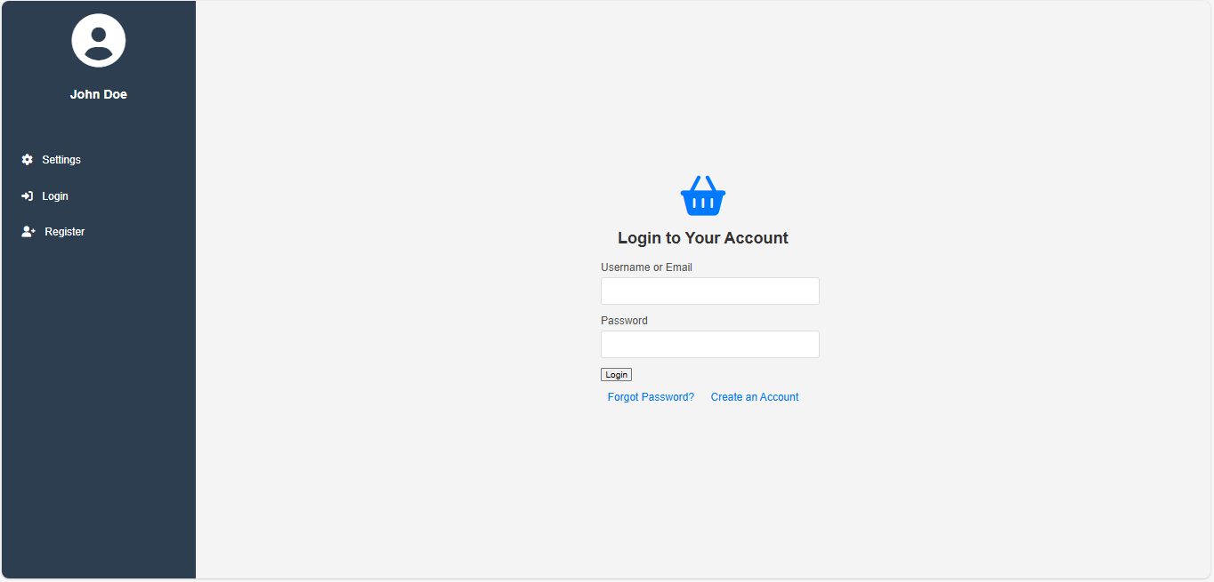

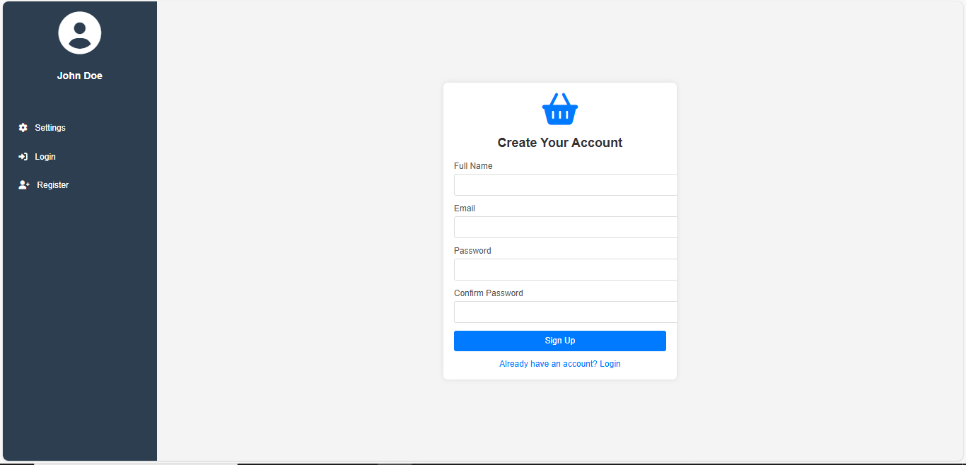

* Dashboard

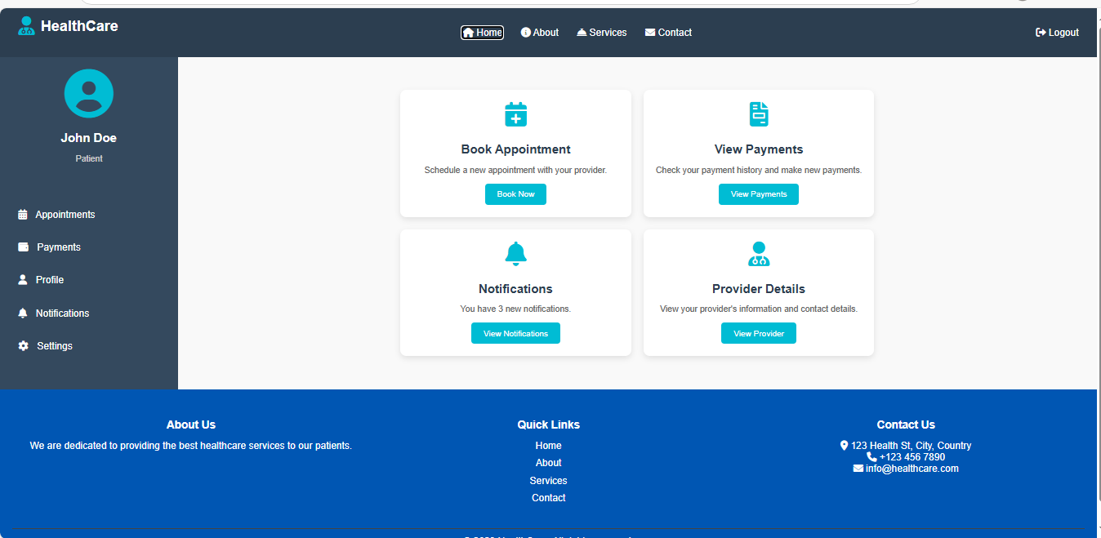

* Provider- dashboard

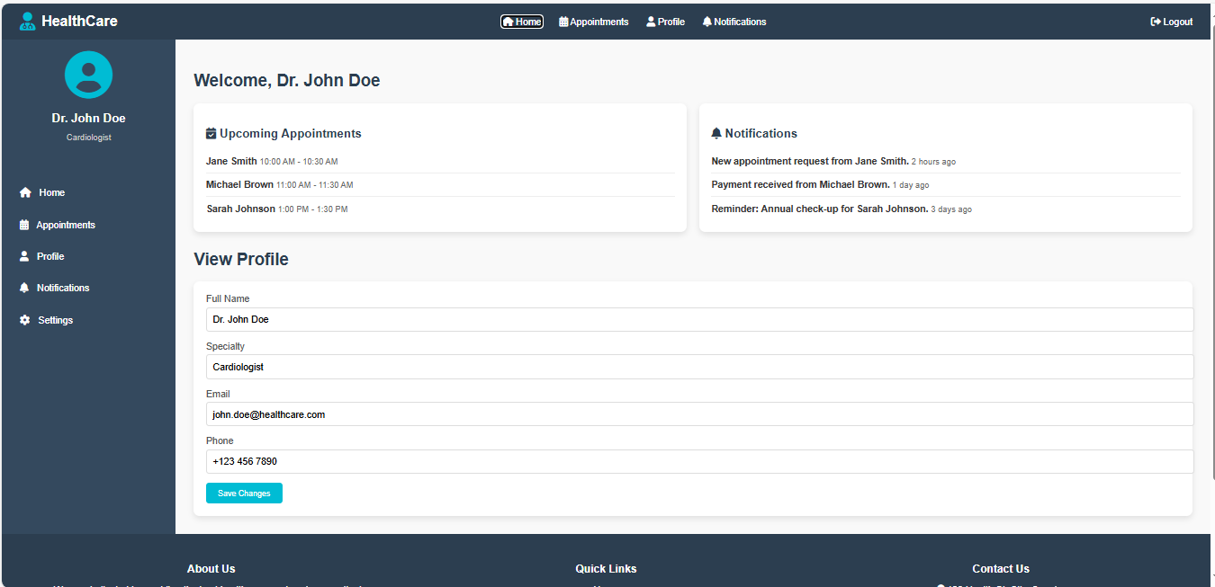

* Admin dashboard


 